Forum: Economic and Social Council (ECOSOC)
Issue: Universal free trade
Student Officer: Kannapat Pattaranavakul
Position: President

Introduction
The World Trade Organisation (WTO) was established in 1995. It is at the centre of the global trading system and is one of the most influential international organisations on trading. Its key purpose is to improve the standards of living for the people, by establishing rules which help trade to flow freely. Their goals are to achieve trade liberalisation (meaning having no government involved with trading) through a variety of actions, including the removal of trade barriers and making sure that all the main participants in the global trade are aware of these rules. They also serve as a forum for trade negotiations amongst its nations, concerning their multilateral trade relations in matters that deal with the WTO Agreement or the various agreements added to it, and for settling trade disagreements.
In recent years the WTO has received intense criticism concerned with the perceived negative impact of its agreements on people’s incomes worldwide. Read General Overview to find out why.

Definition of Key Terms
WTO : World Trade Organization.
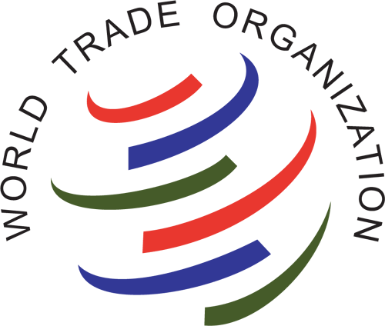
Universal Free Trade: a policy followed by some international markets in which countries' governments do not restrict imports from, or exports to, other countries.

General Overview
Common criticisms are that the WTO isn’t working in the interests of the majority of the nations. One big concern that many might have is that the WTO only serves the interests of big multinational corporations. There are many other concerns with the WTO; For example, that it poses a threat to democracy, the environment, labour laws and nations’ control of their faiths. And that the global trading system does not show the concerns of developing countries but exposes them to the pressures from more powerful and developed countries. Free trade on a global level might also result in a lack of responsiveness towards human rights violations and a lack of transparency in their processes.

Major Parties Involved

- The following countries are categorised by the Enabling Trade Index which is measured using the factors, policies and services which facilitates the trade in goods across borders and to destination. The top 20 countries and areas are: Singapore, Hong Kong, Netherlands, United Kingdom, Japan, Germany, Republic of Korea, United States, France, United Arab Emirates, Switzerland, Spain, Luxembourg, Finland, Taiwan, Denmark, Sweden, Belgium, Austria, Australia.
These countries would have the most influences on the issue as they are the countries who have the most involvement with trading.
- The European Economic Area
- North American Free Trade Agreement
- The European Union

Timeline of Events
January 1st 1994 | The establishment of European Economic Area providing free movement of persons, goods, services and capital within the European Single Market.
January 1st 1994 | The establishment of NAFTA, North American Free Trade Agreement, removing tariff barriers between the Canada, The United States, and Mexico.
April 15th 1994 | The establishment of the WTO, World Trade Organisation.
1999 - 2002 | The establishment of the European Union, enriching all trade within the union.

Previous Attempts to solve the issue
Since we placed an emphasis on The World Trade Organization. In summary of the organisation, it was created to open up markets and promote international trade based on their free trade patterns. The WTO created and monitors agreements to reduce trade barriers, and judge the disputes over foreign market access, and violations of agreements. Its definition of 'Free Trade' is a trade on a level playing field, so that the unlimited exchange of goods between countries is not necessarily always free. Some countries might find the WTO against what their country voices while other countries might agree with the WTO. But, the issue would come down to if countries would agree with having free trade on a universal scale or not.

Possible Solutions
A possibility is for the delegates to place rules and regulations on trading without having costs involved unless delegates find reasons otherwise like violations towards human rights, etc. There are many pros and cons to free trading on a global scale. It is all truly up to the delegates within the committees to weigh out the facts and to decide if the majority is in favour of having a free global trade throughout the world or not. But it is important to also keep in mind that countries shouldn’t be forced into free trading because, as mentioned before, the countries that would benefit most from a globally free trade are the developed countries.

Useful documents & Appendix/Appendices
"Learning to Love Globalisation: Education and Individual Attitudes Toward International Trade." International Organization.
http://journals.cambridge.org/action/displayAbstract?fromPage=online&aid=430731
World Economic Forum. "Rankings: Global Enabling Trade Report 2010”
https://www.weforum.org/pdf/GETR10/GETR10-Overall-Rankings.pdf

"True Free Trade", Chapter 3, Protection or Free Trade
http://www.truefreetrade.org/pft3.htm

"Benefits of Free Trade." Economics Help. N.p., n.d. Web. 03 Sept. 2016.
http://www.economicshelp.org/trade/benefits_free_trade/

