Forum: African Union
Issue: The situation in Libya
Student Officer: Karlijn van der Plaat
Position: Deputy Chair

Introduction
On 17 December 2010, the first uprising in Northern Africa occurred. A man in Tunisia set himself on fire because he did not agree with the way the police force operated. Riots followed afterwards and with success. On 14 January 2011, only one month later, the president of Tunisia fled the country. This was an inspiration for many people in the Northern African countries, many of whom had been suffering from dictatorial regimes.
The population of Libya was also suppressed by a dictatorial regime of its leader Muammar Gaddaffi, who had ruled for 42 years. During the Arab Spring, anti-Gaddafists led by the National Transitional Council (NTC) revolted, starting the Libyan Civil War. Together with NATO intervening military troops, they managed to succeed in a coup, in which Gaddafi was captured and killed by NTC militants.
The Libyans were happy they had won and the NATO called it a successful mission. Yet the country was not as successful in reorganizing the country afterwards. In the aftermath of the revolution elections were held, trying to set up a new governmental body. This failed and it resulted in two bodies not recognizing each other. Thus, the country was ruled by two parliaments and two prime ministers, which caused chaos. By effort of the United Nations, a new government was formed, the Government of National Accord. Yet, the previously existing governments did and still do not recognize this body, which still causes for a division in the country with many singular rebel groups fighting each other. In addition, an Islamist rebel group wants to make Libya an Islamic State, already controlling large parts of land around the city Sirte.
To conclude, Libya is in a very unstable political situation in which the violence is worse than before the first revolution. Many problems are caused by the revolution, that have to be solved.

Definition of Key Terms
Arab Spring
The Arab Spring was a movement of civil protest, demonstrations, riots and civil wars in the Arab world. The first revolution was in Tunisia on 18 December 2010. The protest spread across countries of the Arab League, such as Egypt, Libya and multiple other countries.

NATO
The North Atlantic Treaty Organization (NATO) is an intergovernmental military alliance. It is based on the North Atlantic Treaty signed on 4 April 1949. The members agree to militarily defend each other in response to an attack by any external party.

Civil war
A civil war is a war between two organized groups within the same state or country.

Interim government
“A provisional government also called an interim or transitional government is an emergency governmental authority set up to manage a political transition, generally in the cases of new nations, or following the collapse of the previous governing administration.” (according to Wikipedia)

General Overview
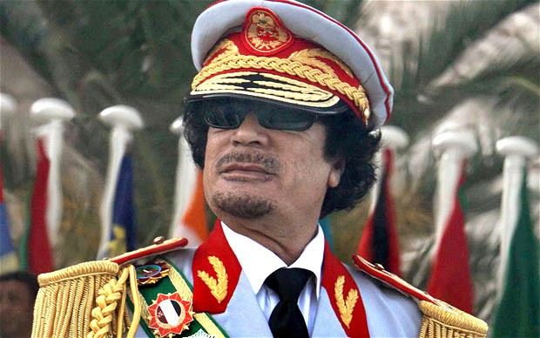
Muammar Gaddafi was the starter of the revolution in 1969 in which they seized control from the absolute monarchy of king Idris. He soon put all the power into his own hands and remained control for 42 years. On Tuesday, 15 February 2011, the first protests arose in Benghazi, the second largest city in the east of Libya. They called for Gaddafi to step down and to release political prisoners. The Libyan security forces used water cannons, tear gas and rubber bullets to stop the protest, injuring multiple people. Since the government of Gaddafi was mostly situated in Tripoli, the capital of Libya in the West, the rebels relatively easy took control over the territory in Benghazi.
Later, unrest spread to Tripoli as well. Because the rebels were gaining power and control over the country, the Libyan security forces started using real violence, killing many demonstrators. This generated international disapproval of the acts of Gaddafi by multiple foreign leaders and human rights organizations. Many politicians resigned from their jobs. Later Libyan military units increasingly started to support the side of the rebels, and the demonstrators got hold of weapons from government depots. This increased the strength of the rebels. The international community started showing more and more support of the rebels as well. Many counties posed sanction on the government of Libya and froze the assets of Gaddafi. Furthermore, an arms embargo was put on the country.
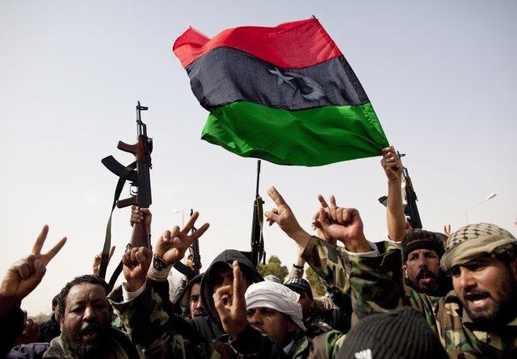
A rebel leadership council was formed by the merging of local rebel groups in Benghazi, called the National Transitional Council. The NTC would be the military leadership and representative of the rebels and it would guide the country’s transition into democracy. After much discussion, the international community imposed a no-fly zone in Libya, in order to prevent air strikes from Gaddafi’s arms.
Thanks to military intervention of the NATO and assistance to the rebels from Britain, France and Italy, the rebels succeeded in taking over control. In September 2011, the rebels gained control over Gaddafi’s headquarters and the city of Tripoli. On October 20, Gaddafi was discovered and killed in his hometown, Sirte, by the rebels. The NTC was then recognized as the representative of the Libyan population and took the role of an interim government.
The NTC prepared elections that were held in July 2012. In this election the NTC handed over their power to the General National Congress (GNC), an elected parliament which would select a head of State. The mandate of the GNC was to expire on 7 February 2014, yet the body extended its own mandate to 24 December 2014. This and the fact that the GNC had not yet succeeded, caused for unrest and protest in the country. A new, democratically chosen parliament was to take over the job, called the Council of Deputies or the House of representatives, which was also recognized by the international community. It was not, however, recognized by the GNC who still operated themselves. This caused for a division in the country, with single rebel groups supporting different parliaments in the conflict.
This caused for a second civil war in Libya in May 2014. The danger of this conflict was that the militias who had also fought in the first civil war still had many arms. The Council of Deputies, situated in the east of Libya, was also backed by Haftar, the military officer of the Libyan National Army. Meanwhile, the GNC was situated in the west and in Tripoli, a militia controlled city.
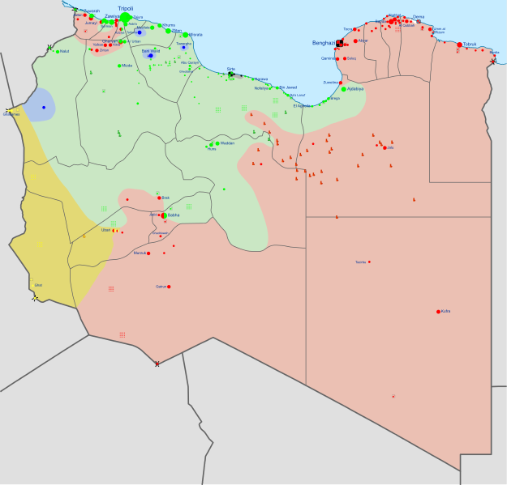
On 17 December 2015, after much discussion, both the GNC and the House of Representatives signed a United Nations-brokered agreement on forming a national unity government, the Libyan Political agreement. In this agreement, the Presidential Council (PC) was set up and received the task of forming a cabinet, called the Government of National Accord (GNA). In this accord, the PC would fill the role of a head of state. The members of these governmental bodies would be elected from both the GNC and the HoR. The HoR would remain the legislative body in the country. However, the GNA that the Presidential council had set up, was not supported by many of the HoR and GNC.
Nowadays, critics also say that the chosen GNA does not evenly represent the country’s groups. What further increases the tension in this conflict is that the UN and the Presidential Council continued the development of the GNA, even though the HoR has not given their consent on the body yet. According to the HoR, this is a violation of the Libyan Political Agreement.
At this moment, there are fights between the rebels supporting the HoR and rebels supporting the GNC. In the map on the right you can see the division among the country, with red being supporters of HoR and green being supporters of GNC. The HoR is supported by Egypt and the United Arab Emirates.
The reason why it is so important to form a unity government in Libya is because the threat of ISIL is increasing in the country. The Ansar-al-Sharia (UN recognized terrorist organization) and other Islamist groups fought together as the Shura Coucil of Benghazi Revolutionaries and conquered quite some territory. They were this successful because the political situation in Libya was so unstable. Some territory has been recaptured by the Libyan National Army and other rebels, however not all has been recaptured yet and the threat of recruitment is high, since the situation is still unstable. Furthermore, the danger of the Islamist organizations placed in Libya is that in Libya large oil reserves can be found. In this way the extremists have an easily accessible source of income, which they can use to further equip themselves.

Another problem in Libya is the fact that without a unity government, it is impossible to have effective border control. The numbers of illegal migration and smuggling are very high in the country, causing for many refugees from entire Africa to have a gateway to Europe.
To conclude, the political and social situation in Libya is very unstable. In the conflict there are many singular rebel groups fighting each other and there is the bigger fight between the two different parliaments, the GNC and the HoR. Many groups and people take and have taken advantage of the unstable situation in Libya, such as the Islamic terrorist groups and human traffickers.

Major Parties Involved
Libya
It is needless to say that Libya is the country most involved in this issue. This country has been in an instable and dangerous situation for over 5 years already. The Libyan population is in need for better circumstances for their own safety and future possibilities. Libya is the fourth largest country of Africa and has the tenth largest oil reserve of the world. The majority of the country is Muslim.
Arab League
The Arab League is compromised of 22 Arabic nations, of which Algeria, Libya, Egypt, Morocco, United Arab Emirates, Saudi Arabia, and others. The Arab League has played an important but neutral role in the Libyan conflict. During the first Libyan civil war, the organisation requested the UN to establish a no-fly zone over Libya. In addition, the organisation called for negotiations upon the instability issue in Libya. Furthermore, they called for negotiations between the GNC and the House of Representatives. The reason that the Arab League is so involved in the matter is because the unrest in Libya poses a possible threat to the member nations. Since they also have had revolutions recently, the political situation in member nations is still unstable. The rebels in Libya are dangerous for the governments in those countries. The threat of smuggling and ISIS is also something that has increased due to the political instability in Libya. Thus, the Arab League benefits from improving the social and political situation in Libya.
The countries in the Arab League mostly involved in the Libyan conflict are the neighbouring countries Egypt and Algeria, and the United Arab Emirates. Egypt and Algeria are trying to protect their own countries from the possible dangers. And the U.A.E. has provided the Libyan National Army with equipment to fight on the side of the House of Representatives.
United States of America
The United States of America has played an active role during the Arab Spring in general and also in the Libyan civil war. In the Libyan conflict they provided help and assistance to the revolutionists and they led the NATO in doing so as well. Furthermore, the country has led NATO in protecting the no-fly zone over Libya. In addition, they sent 8000 military personnel to Libya. Lastly, the Islamist rebels conducted an attack on the United States consulate and killed the ambassador of USA. This increased the actions of the USA regarding the conflict, in favour of the revolutionists.

Timeline of Events
September 1969 | Muammar Gaddafi conducted a coup on the monarchy of Libya and gained control over the country.
15 February 2011 | The protest in Benghazi started, marking the beginning of the first Libyan civil war.
20 October 2011 | Gaddafi was killed and the NTC declares Libya liberated.
July 2012 | First elections were held, organized by the NTC.
11 September 2012 | The Islamic Militants attack the United States consulate and killed the US ambassador to Libya in Benghazi.
7 February 2014 | Mandate of the GNC was supposed to be expired, yet the GNC unilaterally extended the mandate to 24 December 2014.
May 2014 | The second Libyan civil war began.
July 2014 | Islamist extremists were reported to have killed some 270 lawyers, judges, activists, military officers, and policemen in order to take over Benghazi.
17 December 2015 | The creation of the Libyan Political agreement.
January 2016 | UN announced the new interim government, but neither HoR nor GNC recognised its authority.
March 2016 | The new unity government arrives in Tripoli by boat after the opposing groups block the air space.
Previous Attempts to solve the issue
The main previous solution for this problem was the establishment of the Libyan Political Agreement and the negotiations around it. This UN-brokered agreement on forming a new government was supposed to create a unity government to increase the stability in the Libyan political situation. However, both of the rival parties did not recognize the product of the agreement, namely the Government of National Accord.

Another attempt to solve the situation was the support mission in Libya, UNSMIL (United Nations Support Mission in Libya). The mission was established in September 2011, during the first Libyan civil war. In the resolution 2144 made in March 2014, the mission received a new task and different mandate from the security council. Presently, its task is to ensure the transition into democracy by providing assistance and advice, to protect the human rights especially those of vulnerable groups by fully implementing the transitional law, to control unsecured arms and to counter the proliferation of it.
(you can read the full mandate here: http://unsmil.unmissions.org/Default.aspx?tabid=3544&language=en-US )
Yet, looking at the fact that this mandate was already created in 2014, it seems not to be as effective as it was thought to be, since the situation has deteriorated to the situation it is in currently. In addition, the Libyan population has lost faith in the UN and most of the people do not want the United Nations to interfere with the situation in Libya. They have become sceptic of Western and foreign help; thus it is risky to use that as a solution. This might cause for people to be recruited or turn to the wrong side in the conflict, as often they propagate the fact that these organizations and rebels are against the Western world.

Possible Solutions
Possible solutions would be to provide the rebels and revolutionists with equipment. However, due to the high instability in the country, the risk of getting arms into the wrong hands is high. Thus, it would be more effective to create a good network system and infrastructure for the delivery of equipment. In addition, the equipment that the rebels need is not only arms, but also medicines, clothes, shoes, as these things are often lacking.
There are often enough arms in Libya, yet most often they are in the wrong hands, thus a good part of the solution is to try to disarmer the terrorist organizations and other groups taking advantage of the instability of the political system. This might be accomplished by diminishing the illegal trade of weaponry and by increasing the border security. However, take in mind the fact that the borders of Libya cover a large distance and that most of it is situated in the desert.
Lastly, it is very important to increase the political stability. However, as previously mentioned, most of the population, including both governments, have become sceptic of the UN and foreign aid. Thus, it is important to find a way in which the population of Libya themselves can improve the situation, with as limited help as possible from foreign organizations.

Appendix/Appendices and useful documents
Wikipedia on the facts and figures:
- https://en.wikipedia.org/wiki/Libyan_Civil_War_(2011)
- https://en.wikipedia.org/wiki/Aftermath_of_the_2011_Libyan_Civil_War
- https://en.wikipedia.org/wiki/Muammar_Gaddafi
- https://en.wikipedia.org/wiki/Ansar_al-Sharia_(Libya)
- https://en.wikipedia.org/wiki/Libyan_Civil_War_(2014%E2%80%93present)
News articles upon the situation
- http://www.theguardian.com/world/interactive/2011/mar/22/middle-east-protest-interactive-timeline
- https://www.theguardian.com/world/2016/feb/16/libya-gaddafi-arab-spring-civil-war-islamic-state
- http://www.bbc.com/news/world-africa-13755445
- https://www.britannica.com/event/Libya-Revolt-of-2011
- https://www.theguardian.com/world/2016/may/16/world-powers-prepared-arm-un-backed-libyan-government
- https://www.theguardian.com/world/2016/mar/13/libyan-unity-government-moves-to-take-power-as-sole-ruling-authority
- http://www.aljazeera.com/news/2016/01/libya-unity-government-160119093015333.html
- http://www.aljazeera.com/news/2016/01/libya-parliament-rejects-backed-unity-government-160125160858643.html
- http://nationalinterest.org/feature/libyas-new-unity-government-anything-16036
BBC facts and figures about Libya
- http://www.bbc.com/news/world-africa-13754897
- http://www.bbc.com/news/world-africa-13755445

UN sources
- http://unsmil.unmissions.org/Default.aspx?tabid=3545&language=en-US

Youtube videos explaining the situation
- https://www.youtube.com/watch?v=jAEix8-Zk2U
- https://www.youtube.com/watch?v=Wc2-1s-c8_g

