Forum: African Union
Issue: Terminating malaria
Student Officer: Adam Solčanský
Position: Chair

Introduction
Malaria is a mosquito infectious disease that is caused by the P. falciparum parasite and transmitted into humans´ bloodstream by female Anopheles (Greek anofelís: “useless”) mosquitos. This happens by the transmission of the saliva of mosquitos into a person´s blood.
The incubation period lasts 7 to 30 days. The first symptoms such as fever, headache, vomiting and chills appear between 10 – 15 days. Without proper treatment, P. falciparum causes death.
Only in 2015 there were 214 million new cases of malaria and about 400,000 people died because of malaria. In 2000 there were 106 countries facing malaria. About 90% of all malaria deaths occur in sub-Saharan Africa. Thanks to the Global Malaria Programme introduced by WHO this number dropped to 95 countries in 2015. In the continent Africa the number of new cases of malaria dropped about 12% in the last 15 years and about 37% worldwide.

Definition of Key Terms

WHO
World Health Organization is a specialized organization of the United Nations, focused on global healthcare.

Red cross
International humanitarian movement providing humanitarian aid to countries suffering from diseases or natural disasters.

Doctors without borders
International, humanitarian, non-governmental organization providing humanitarian aid to countries suffering from diseases or wars.

Epidemia
A widespread outbreak of an infectious disease.

Pharmacopoeia
Pharmacopoeia literally means drug-making. It is a book containing directions for the identification of compound medicines.

General Overview
Everything started in the 1880s when the malaria transmitting parasite was discovered. Malaria has existed for 50,000 – 100,000 years, but it was discovered only in the 19th century. The first studies about malaria were made by Charles Louis Alphonse Lavera, a doctor in the French army, in 1880 in Algeria. Until then the malaria was simply described as a fever.
Malaria developed not more than 10,000 years ago, as a response to human activities in agriculture and settlements.
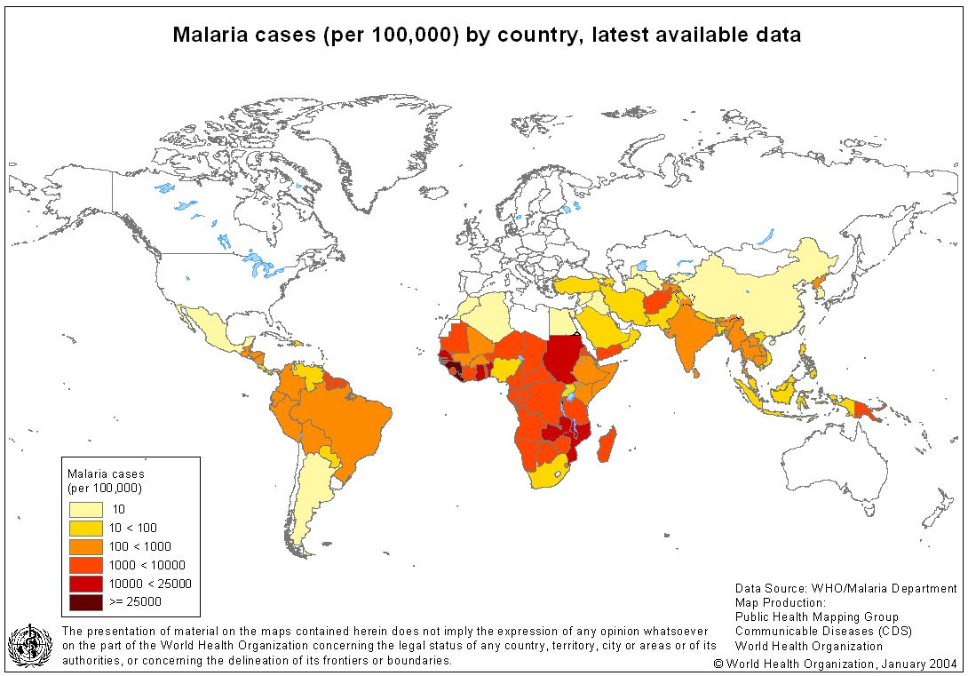
Malaria is special for its drug resistance. The first treatment of malaria came from the cinchona tree, which contains quinine. Its effectiveness against malaria was found and the Jesuits introduced the treatment to Europe around 1640. By 1677, it was included in the London Pharmacopoeia as an antimalarial treatment. Quinine became the predominant malarial medication until the 1920s, when other medications began to be developed. In the 1940s, chloroquine replaced quinine as the treatment of malaria, until resistance supervened, first in Southeast Asia and South America in the 1950s and then globally in the 1980s. [History of malaria on Wikipedia]
The medicinal value of Artemisia annua has been used by Chinese herbalists in traditional Chinese medicines for 2,000 years. In 1596, Li Shizhen recommended in his "Compendium of Materia Medica", tea made from qinghao specifically to treat malaria symptoms. Artemisinins, discovered by Chinese scientist Tu Youyou and colleagues in the 1970s from the plant Artemisia annua, became the recommended treatment for P. falciparummalaria, administered in combination with other antimalarials as well as for other severe diseases. Tu mentions that she was influenced by a traditional Chinese herbal medicine source, The Handbook of Prescriptions for Emergency Treatments, written in 340 by Ge Hong For her work on malaria, Tu Youyou received the 2015 Nobel Prize in Physiology or Medicine. [History of malaria on Wikipedia]
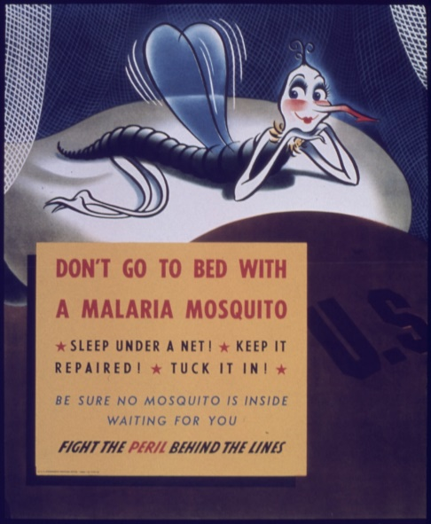
Malaria vaccination is an unachieved goal of modern medicine. The only suitable way in modern history to treat malaria is prevention. Prevention of malaria includes using repellent against mosquitos, mosquito nets, etc. In Africa in 2016 one of four children is still not protected by these nets.
Over the past 15 years there has been a huge descent in the number of malaria cases. The number of new cases decreased by about 37% globally. But only in 2015, still 400,000 people died on malaria and the estimated number of new cases of malaria is 214 million.
The Red Cross and WHO are helping to solve this issue by distributing humanitarian aid to affected areas suffering from malaria. The WHO made a Global Malaria Programme, which introduces the Global Technical Strategy for Malaria. Its goal is to reduce malaria cases by at least 90% by 2030.

Major Parties Involved

WHO
The World Health Organization makes a good chance of changing the number of deaths caused by malaria and the number of new cases, with its Global Malaria Programme and strategy for the next 15 years. Operating worldwide but mainly in Africa due to its low level of development, people do not prevent themselves against dangerous mosquitos as they do in countries of South America.

Sub-Saharan African Countries
The Sub-Saharan African region is considered as a much infested area with malaria. Data from 2014 show differences in reducing new malaria cases and deaths in this area of 50% to 74%. The most affected countries are Sudan, Chad, Somalia, Gabon, Ghana, Guine. In Zimbabwe and Mauritania there exists an estimated increase of the mortality rate caused by malaria.

Timeline of Events

January 1945 Discovery of DDT pesticide by Hermann Muller, which was exclusively used to combat malaria.

January 1951 Elimination of malaria in the US.

January 1955 Global Malaria Eradication Programme launched by the WHO, which excludes Sub-Saharan Africa.

January 2001 WHO prequalified the first malaria treatment, called Artemisnin Combination Therapy (ACT).

January 2002 Establishment of a global fund to fight malaria, AIDS and tuberculosis.

January 2008 Reduced mortality rate on malaria.

Previous Attempts to solve the issue
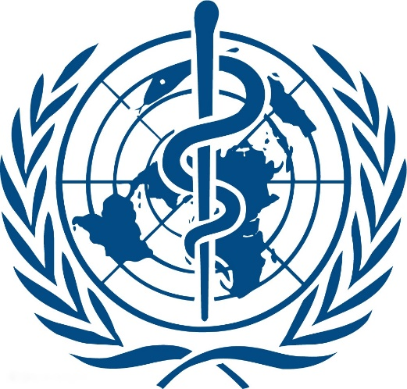
The Global Malaria Eradication Programme, established in 1955 by the WHO and working until 1970 was the first global programme which was ought to help in the fight against malaria. About 50 countries joined this programme (these do not include Sub-Saharan Africa).

The main weapon in this programme was to use the DDT pesticide against malaria, but in most countries the effect lasted for a very short time or the programme failed. This strategy mostly had effects in countries that are in a moderate climate zone.

Possible Solutions
At this point, the most obvious solution is to sponsor the Global Malaria Programme introduced by WHO and its Technical Strategy for Malaria, of which the operative period is from 2016 to 2030. Its goal is to decrease the number of deaths caused by malaria by 90%.
Because malaria is treatable and preventable, other solutions could be to provide humanitarian aid, or to cooperate with countries suffering from malaria worldwide, as well as with other African countries. Creating something such as an “Africa against malaria” union, with its own funds and support of many countries and their governments, can make a huge progress in fighting malaria, mainly in countries which are economically unstable and not able to provide help to people suffering from malaria.

Appendix/Appendices and useful documents

Wikipedia pages about malaria, organizations, medicines and first anti-malaria programme:
- https://en.wikipedia.org/wiki/Malaria
- https://en.wikipedia.org/wiki/Artemisinin
- https://en.wikipedia.org/wiki/World_Health_Organization
- https://en.wikipedia.org/wiki/International_Red_Cross_and_Red_Crescent_Movement
- https://de.wikipedia.org/wiki/Global_Eradication_of_Malaria_Program
(sorry, found only in German )

WHO pages about malaria and the Global Malaria Programme:
- http://www.who.int/topics/malaria/en/
- http://www.who.int/malaria/about_us/en/
- http://www.who.int/malaria/en/
- http://www.emro.who.int/entity/malaria-control-and-elimination/index.html

News article about progress in Malaria:
- http://www.bbc.com/news/health-34269314

Timeline of all malaria events:
- http://www.tiki-toki.com/timeline/entry/194878/Malaria/#vars!date=1814-05-01_04:57:55!

World malaria summary 2015:
- http://apps.who.int/iris/bitstream/10665/205224/1/WHO_HTM_GMP_2016.2_eng.pdf?ua=1

Youtube video explaining the World malaria programme:
- https://www.youtube.com/watch?v=x74I-4BZnRo

