Forum: Security Council
Issue: ISIL
Student Officer: Hashim Bagabas
Position: President

Introduction
The Islamic State of Iraq and the Levant (ISIL), also referred to as the Islamic State of Iraq and Syria (ISIS) and more commonly known as Daesh in the Arab World is a terrorist militant group located in the north of Arabia. ISIL was originally founded in 1999 under the name of Jama'at al-Tawhid wal-Jihad. Al-Zarqawi, the Jordanian militant Islamist, founder and former leader of the organization pledged allegiance to the al-Qaeda leader Osama bin Laden in October 2004. By June 2014, the Islamic State declared itself a Caliphate led by Abu Bakr al-Baghdadi, the “caliph”, which claims religious, political and military authority over all Muslims worldwide. ISIL aims to extend its borders to conquer all of Iraq, the Levant and beyond. In the past years, ISIL has been labeled as a terrorist organization by many countries and several international organizations including the United Nations (UN) due to their adoption of extremist Islamic ideology. The extreme interpretation of Islam followed by the jihadi fighters promotes religious violence, and regards those who do not agree with its interpretations as infidels. ISIL’s ideology of declaring itself an Islamic Caliphate has been widely criticized by mainstream Muslims as the terrorist organization does not depict the true essence of Islam; resulting in various governments and Muslims groups rejecting ISIL’s statehood or caliph-hood.
Definition of Key Terms
Islam: one of the three Abrahamic religions practiced around the world with over 1.6 billion followers, of which 90% categorize themselves as Sunni Muslims.

Quran: Islam’s holy book. The name translates as “the recitation”.

Levant: geographical term referring to a large area in the eastern Mediterranean.

Daesh: acronym for Al Dawla al-Islamiya fil Iraq wa’al-Sham, Arabic for Islamic State in Iraq and the Levant. Often used as a pejorative term for the Islamic State terror group.

Kafir: Arabic term meaning unbeliever or infidel, used to refer to non-Muslims.

Jihad: an Islamic term translating from Arabic as “struggle”, this is the term used for the holy war against unbelievers which Islamists see as their religious duty.

Al-Qaeda: a militant Sunni Islamist multi-national organization founded in 1988 by Osama bin Laden, Abdullah Azzam, and several other Arab volunteers who fought against the Soviet invasion of Afghanistan in the 1980s. The group rivals ISIS for the global jihadi leadership.

Sunni: one of the two main branches of Islam following the teachings of Prophet Mohammed, differing from Shia in its understanding of the Sunna and in its acceptance of the first three caliphs.

Shia: one of the two main branches of Islam, followed by about a tenth of Muslims, especially in Iran, that rejects the first three Sunni caliphs and regards Ali, the fourth caliph, as Muhammad's first true successor.

Dabiq: The Islamic State’s English-language propaganda magazine.

Mufti: a Muslim legal expert who is empowered to give rulings on religious matters

Caliph: a spiritual supreme leader of Islam, claiming succession from Muhammad.

Caliphate: form of Islamic government led by a caliph.

Sharia Law: the religious law governing the members of the Islamic faith.

Yazidi: a member of a religious sect mostly in the Kurdish areas of northern Iraq, Syria, Armenia, and Georgia, whose beliefs are based partly on Zoroastrianism and Sufism.

Kurd: a member of an Islamic people speaking Kurdish and dwelling chiefly in Kurdistan (northern Iraq).

Kurdistan: broad geographic region inhabited mainly by ethnic Kurds including parts of eastern Turkey, northern Iraq, western Iran, northern Syria and southern Armenia.

General Overview
The so called “Islamic State”(IS) established itself as in Islamic Caliphate on 29 June 2014 and named itself The Islamic State of Iraq and the Levant. The beheadings, shootings, and suicide bombings of civilians and foreigners by IS have been condemned not only by Muslim majority countries but also by International Governments and Organizations. IS militants make up 0.001% of all Muslim population. After the rise of ISIL, the Grand Mufti of Saudi Arabia, Abdul-Aziz ibn Abdullah Al ash-Sheikh, condemned ISIL and al-Qaeda in late August 2014 saying, “Extremist and militant ideas and terrorism which spread decay on Earth, destroying human civilization, are not in any way part of Islam, but are enemy number one of Islam, and Muslims are their first victims”.
The number of ISIL militants within Iraq and Syria have not been confirmed. Each opposition in the war against ISIL gives different estimates. For instance, ISIL leaders claim that they command 40,000 fighters. In early 2015, the number of fighters was estimated by the CIA at 31,000, with foreign fighters accounting for around two thirds. On the other hand, the Kurdish claim that there is a whopping number of 200,000 militants fighting for ISIL. To a 21st century historian studying this case, the number of militants could range from 45,000 to 250,000 fighters.
Ever since their establishment, Abu Bakr Al-Baghdadi has been aiming to extend ISIL’s boundaries to conquer all of Arabia and the Muslim World, and their leader has been successful thus far due to the effective methods used to recruit jihadists. Al-Baghdadi seems to offer lonely, depressed people who lost their way a reason to live; to fight for triumph. Moreover, ISIL has a strong financial status that lures in those who are unemployed as they get well paid. For example, as of December 2015, the number of fighters from Tunisia in ISIL exceeded 6,000 due to poor economic conditions and disillusionment following the 2011 Arab Spring uprising. Furthermore, IS uses up-to-date attractive social media that appeals to the youth. The state uses professional alluring filming techniques such as High-Quality videos with the use of angles and different types of lenses meaning that ISIL’s political propaganda is very strong as the number of recruitments keep rising. Dabiq, the Islamic State’s magazine used for propaganda and recruitment, was first published in July 2014. ISIL states the magazine is for the purposes of unitarianism, truth-seeking, migration, holy war and community. The execution and writing of the articles and its form is professional showing that there is a large number of employees working for ISIL to write and polish the magazine. In essence, ISIL functions as an independent entity which may impose a direct threat to global security.
- Major Parties Involved
The situation in the Middle East is very complex at the moment. After the rise of ISIL in the region and the start of the Syrian civil war, the conflict is divided into four different sides on the ground: ISIL, the Kurds, Bashar Al-Assad’s Regime, and the Syrian Rebels. Each of these sides have different foreign allies that have different motives and aims in the region. In the end, the issue establishes the region as a great-powers dispute.

ISIL
IS aims to take control of the whole region and to govern all muslims and eradicate the “kufar” living in the area. They are taking advantage of the insurgency in Syria as the terrorist organization keeps advancing and seizing control of new territory daily. It does not fight Assad in the region, instead it fights other rebel groups such as the Kurds and Free Syrian Army.

Syrian Rebels (Free Syrian Army)
As the peaceful protests of 2011 quickly escalated to a bloody revolution and civil war. The Syrian people formed a military group to resist against Al-Assad’s Regime. The Rebels are backed by many foreign powers as they aim to topple down Assad from power to reinstitute a democratic government and insure stability in the region.

Gulf States
By 2012, Gulf Arab States start sending money and weapons to the Free Syrian Army through Turkey and Jordan to fight the opposition and undermine Iran’s influence in the region.

USA
Horrified by the acts against humanity committed by the Assad Regime, The Obama Administration is rumored to have signed a secret order authorizing the CIA to train and equip the Syrian Rebels.

Kurds
After the breakout of the war, the Kurds take up arms to rebel against Assad. Bordering Syria to its North is Turkey. Turkey sees the Kurds as a direct threat to Turkey’s sovereignty.

Turkey
By August 2014, Turkey sees the direct threat posed by the Kurds. The government begins to bomb the Kurdish groups in the region. ISIL is also fighting in the same region and posing a threat to Turkey’s nation-state, but Turkey only attacks the Kurds and not ISIL.

Syrian Assad Regime
As the Arab Spring movements spread through the Arab World in 2011, it also infected Syria. This was the beginning of a civil war against the government led by Assad.

Iran
Assad’s most important ally. Since the start of the war, Iran has been sending weapons and officers on the ground to maintain the sovereignty of the Syrian Government.

Hezbollah
The Lebanese Shia group backed by Iran invades to fight alongside Bashar Al-Assad.

Russia
In September 2015, Russia intervenes on Bashar’s behalf. Russia claims it is there to attack and bomb ISIL.

Timeline of Events
Date | Event
1999 | Established of Jama'at al-Tawhid wal-Jihad
October 2004 | Joined al-Qaeda
13 October 2006 | Declaration of an Islamic state in Iraq
8 April 2013 | Claim of territory in the Levant
January 2014 | ISIL takes over Raqqa and declares it the capital of the ISIL emirate
3 February 2014 | Separated from al-Qaeda
18 June 2014 | Iraq asks the United States to conduct airstrikes against ISIL
29 June 2014 | Establishes the caliphate and rebrands itself as the “Islamic State”
13 November 2014 | Claim of territory in: Libya, Egypt, Algeria, Saudi Arabia, Yemen
7 August 2014 | President Obama announces the beginning of airstrikes against ISIL in Iraq.
29 January 2015 | Claims territory in parts of South Asia
4 Febuary 2015 | ISIL releases a video of Jordanian military pilot Moaz al Kasasbeh being burned alive
12 March 2015 | Claims territory in Nigeria
18 March 2015 | ISIL claims responsibility for an attack on the Bardo museum in Tunis, which killed 22 people
22 May 2015 | ISIL claims responsibility for the suicide attacks on a Shi’ite mosque in eastern Saudi Arabia, which killed 21 people and injured more than 100
23 June 2015 | Claims territory in North Caucasus
July 2015 | Destruction of Palmyra, a cultural heritage site
14 January 2016 | ISIL claims responsibility for an attack in Jakarta, Indonesia, that killed at least two people and injured 19 others
19 March 2016 | A suicide bomber kills five people and injures dozens of others in Istanbul. The Turkish Interior Ministry announces that the perpetrator had links to ISIL
3 July 2016 | ISIL militants carry out a suicide bombing that kills more than 200 people on a busy shopping street in Baghdad. The attack, which occurred during the Muslim holy month of Ramadan, was ISIL’s deadliest bomb attack on civilians to date
14 July 2016 | A 31-year-old Tunisian man drives a truck through a crowd in Nice, France, and kills 84 people. ISIL claims the attack.

Previous Attempts to Solve the Issue
United Nations Action To Counter Terrorism
The UN Global Counter-Terrorism Strategy is a unique instrument to enhance the efforts of the international community to counter terrorism along four pillars:
- Addressing conditions conducive to the spread of terrorism;
- Preventing and combatting terrorism;
- Building Member States’ capacity to prevent and combat terrorism and to strengthen the role of the United Nations system in this regard;
- Ensuring the respect for human rights for all and the rule of law as the fundamental basis for countering terrorism.
The General Assembly also endorsed the Counter-Terrorism Implementation Task Force (CTITF). Consisting of 38 entities of the UN and affiliated organizations, CTITF works to promote coordination and coherence within the UN System on counter-terrorism and to provide assistance to Member States.

Special Envoy of the Secretary-General for Syria
Staffan de Mistura was appointed by Ban Ki-Moon, the Secretary-General (SG) of the UN on 10 July 2014 as the new special envoy of the SG for Syria tasked with seeking a peaceful resolution of the conflict in Syria although no political solution has been passed due to the complexity of the situation.

Possible Solutions & Approaches
- Delegates should not treat this conflict as a two-sided conflict. There is more than one force in Iraq and Syria against ISIL. In Syria, there is the Syrian armed forces, the Free Syrian Army and Al-Nusra Front. In Iraq, there is the Iraqi Armed Forces (mostly Shia), Peshmerga (Kurdistan Army) and the tribal army (mostly Sunni).

- Delegates should not limit the debate to Iraq and the Levant region, but must also acknowledge the expansion of the state into North Africa. Also delegates should treat this as an international crisis rather than a regional one. Terrorist attacks claimed by ISIL have occurred all over the world. Also, we have seen other terrorist groups show their support to the Islamic State, for instance, Boko Haram in Nigeria, Ansar Al-Sharia in Libya and Tunisia and the Islamic Movement of Uzbekistan.

- Air strikes have been already implemented on Iraq and Syria. Now if the delegates want to combat ISIL and eliminate the organization they might need to expand the military intervention. This must always be discussed in regional context and with regards to neighboring countries. In addition, delegates must decide if military intervention will be of an offensive or defensive nature. If agreed upon military action should be taken with regards to which country will be leading and cooperation with neighboring countries.

- Delegates should also look at the conflict beyond the fighting terrain and discuss the possibilities of fighting ISIL economically, perhaps by reaching their source of finance and hindering it by imposing sanctions or other penalties.

Useful documents and sources
Security Council Adopts Resolution 2170 (2014) Condemning Gross, Widespread Abuse of Human Rights by Extremist Groups in Iraq, Syria:
http://www.un.org/press/en/2014/sc11520.doc.htm

Resolution 2249 (2015) Adopted by the Security Council on 20 November 2015 calling for member states to take all necessary measures on the territory under the control of ISIS to prevent terrorist acts committed by ISIS and other Al-Qaida affiliates:
http://www.securitycouncilreport.org/atf/cf/%7B65BFCF9B-6D27-4E9C-8CD3-CF6E4FF96FF9%7D/s_res_2249.pdf

Resolution 2253 (2015) Adopted by the Security Council on 17 December 2015 addressing the issue of ISIL and strengthening the Al-Qaida sanctions regime:
http://www.un.org/en/ga/search/view_doc.asp?symbol=S/RES/2253(2015)&referer=/english/&Lang=E

Short video explaining the rise of the Islamic State:
https://www.youtube.com /watch?v=pzmO6RWy1v8

Short video explains who’s fighting and why in Syria’s War:
https://www.youtube.com/watch?v=NKb9GVU8bHE

ISL Demographics: http://www.bbc.com/news/world-middle-east-27838034

Security Council Report:
http://www.securitycouncilreport.org/un-documents/terrorism/

Ways of Achieving A Diplomatic Solution In Syria:
http://www.huffingtonpost.com/admiral-jim-stavridis-ret/bombing-isis-diplomatic-syria_b_8557148.html

UN Security Council holds urgent meeting on Syria:
https://www.facebook.com/RTnews/videos/vb.326683984410/10154718026489411/?type=2&theater

Bibliography
http://www.theatlantic.com/magazine/archive/2015/03/what-isis-really-wants/384980/
http://www.ice-news.net/2015/06/24/the-isis-dictionary-key-words-and-meaning/
http://www.dictionary.com/
https://www.theguardian.com/world/isis
http://www.bbc.com/news/world-middle-east-24179084
https://en.wikipedia.org/wiki/Islamic_State_of_Iraq_and_the_Levant
http://www.bbc.com/news/world-middle-east-27838034
https://www.wilsoncenter.org/article/timeline-rise-and-spread-the-islamic-state
http://www.un.org/en/counterterrorism/
http://www.zwemercenter.com/sample-post-with-a-title/

Appendix

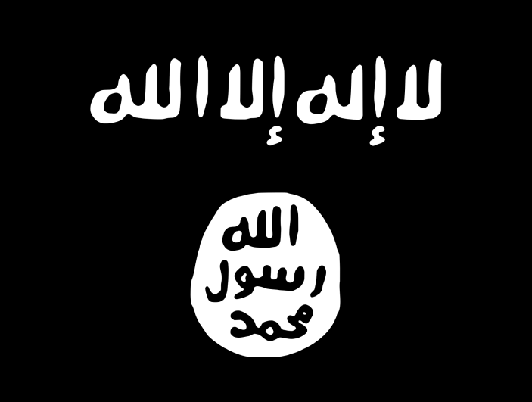
ISIL’s Flag

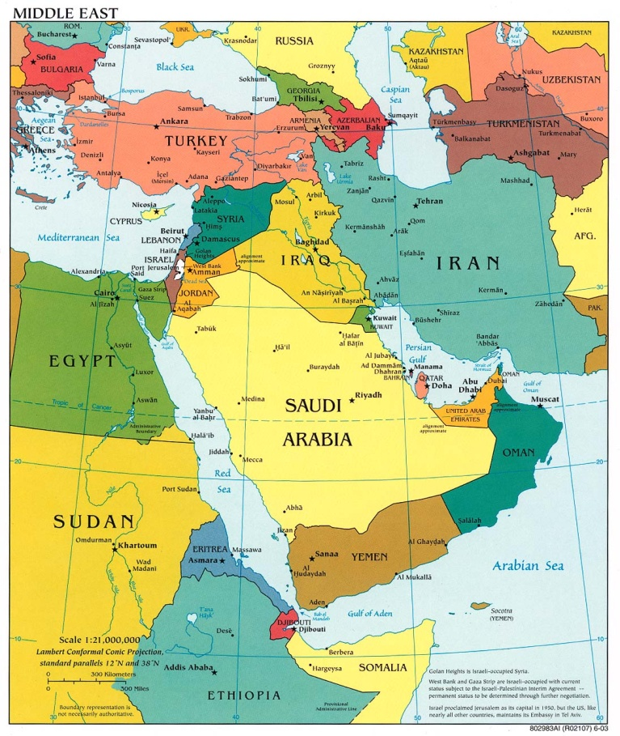
Map of the Region

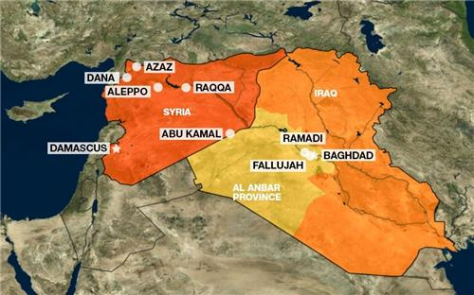
Map of Iraq and Syria

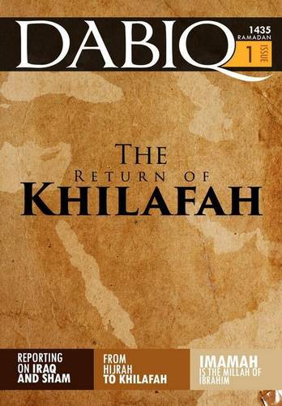
Dabiq’s first issue

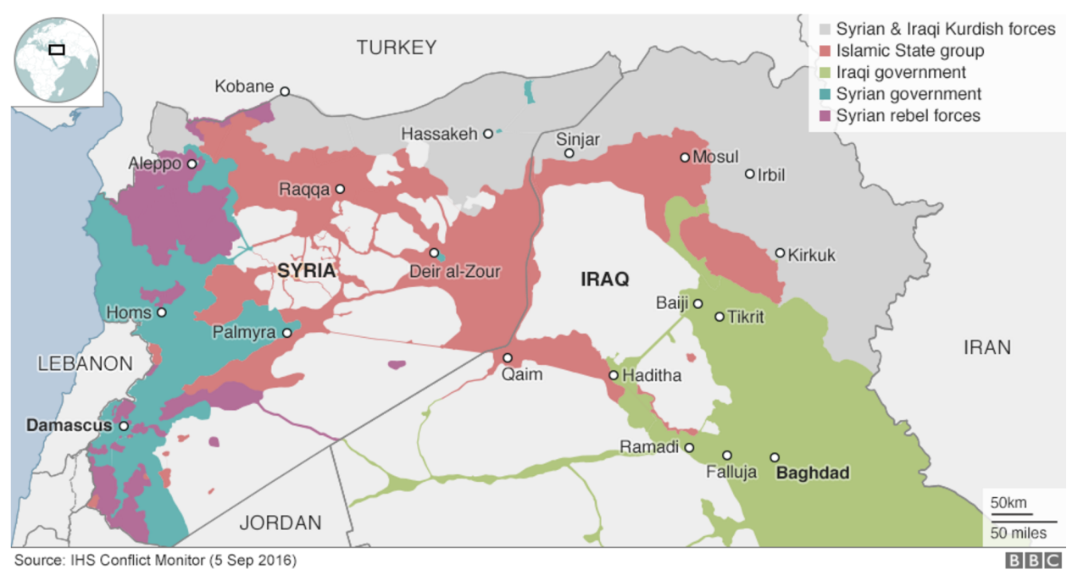
Division of Power in the Region

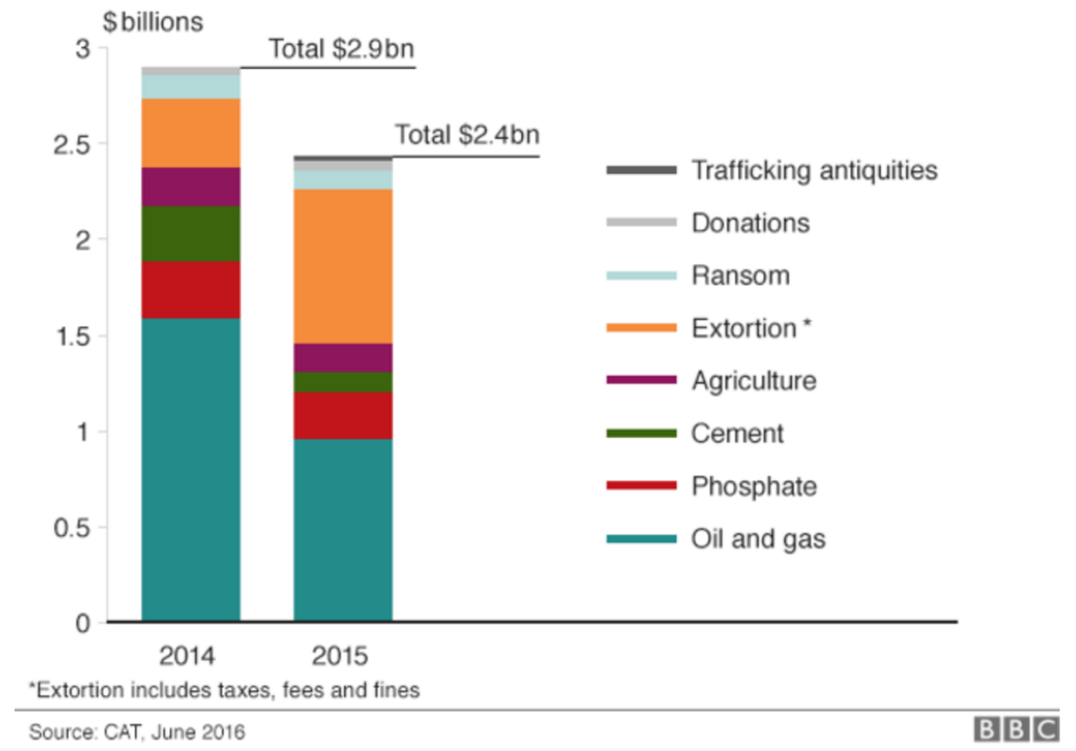
ISIL’s sources of revenue

