Forum: Environmental Commission
Issue: Fracking
Student Officer: Ifigeneia Paschali
Position: Deputy Chair

Introduction
It is widely known that at some point the world will run out of oil. From an environmental perspective this could be considered a positive development, specifically in relation to climate change, however it also poses a major energy challenge. The question is whether fracking could contribute to solving this problem. Fracking, or hydraulic fracturing, is a method of extracting oil and natural gas from underground rock formations. Although at first glance fracking seems a very effective, economic and practical solution, when we examine it more deeply we can see that things are more complicated. The process requires use of great amounts of water, chemicals and sand and thus has serious impacts on human health and the environment. After the fracking revolution in 2013 in the USA, researchers have shown that the environmental destruction close to fracking sites isn’t irrelevant to the procedures and have confirmed that they may also threat human health and well-being. Various other arguments have been used in favour or against fracking. For example, on the one hand investing in renewable energy could be considered a more environmentally friendly solution to the world energy challenge, while on the other hand natural gas extracted through fracking is already better than coal in terms of climate impact. Since 2013 the USA has seen great economical benefits that have been attributed to increased fracking activities. All in all, we need to ask ourselves whether fracking will, in the long run, benefit us more or harm us more , and how can we make the process less harmful for us and the environment. Can the problems be faced with proper regulations to minimize the possible damage? What can we do at the UN level and where does each country’s own sovereignty come in?

Definition of Key Terms
Fracking: The process of extracting oil or natural gas by injecting a mixture of water, sand or gravel, and certain chemicals under high pressure into well holes in dense rock to create fractures that the sand or gravel holds open, allowing the oil or gas to escape.

Shale formations: A fissile rock composed of layers of claylike, fine-grained sediments.

Reservoirs: A subsurface, porous, permeable rock body in which oil and/or gas have accumulated.

Methane: A colorless, odorless gas, the simplest paraffin hydrocarbon. It is the principal constituent of natural gas and is also associated with crude oil.

General Overview
Geologists have known for years that deposits of oil and natural gas are trapped underground, in shale formations created millions of years ago. Today, the required technology has been developed and with the process of fracking, the oil and gas in the shale reservoirs are being produced and gathered all around the world.
Fracking, also known as hydraulic fracturing, is a popular method of energy production. This industrial process is based on the breaking of underground rock formations so as to extract fossil fuels like oil or methane gas. Although it’s primitive origins can be traced to the 1960’s, it was first conducted experimentally in 1947 and commercially in 1949. In it’s current form, which naturally is technologically superior to those of the previous century, it was primarily seen in 1999 at an operation in Texas, USA.
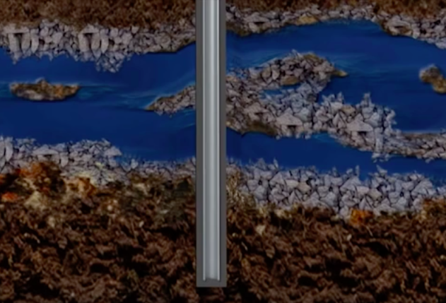
The process consists of 3 phases: the well-making, the product extraction, and the sealing of the well, after the source is exhausted. The shale reservoirs are usually more than one mile under the surface, and also well-below any water sources, which usually are found 300 to 1000 feet below the surface. This means that most of the times the well passes through freshwater aquifers, and as a result there is need of protective measures so as to not contaminate the water source. The first phase (the making of the well) begins with a hole being drilled down using mainly freshwater based fluids. When the hole exceeds the deepest water aquifer, the drilling pipe is removed and replaced with a steel pipe. In order to keep the pipe in place and also add a protective layer between the water source and the hole, cement is pumped down the steel pipe and when it reaches the bottom, it is pumped down and then up between the pipe and the ground (image 1). Fracking is an extraction process that differs from the usual ones, mainly due to the horizontal drilling that is required. After the cement has been placed, the drilling pipe is again thrown down, and this time it follows a curve-like direction and then drills horizontally into the selected rock. The horizontal drilling has the benefit that we are able to have more than wells with one drilling. After the desired length is reached, the drilling pipe is removed, and a steel case is placed, and is once more cemented in place. Then, a perforating gun is thrown down the hole. The gun creates cracks through the steel pipe, cement and then into the rock. The gun is removed and the fracking fluid is pumped in.
Image 1:
Securing steel pipe with the help of cement
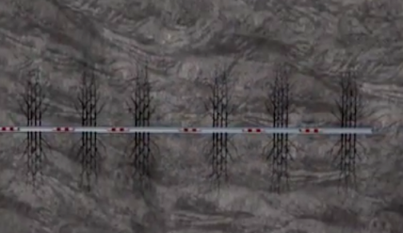
The fracking fluid consists mainly of water, sand and some chemicals. Specifically, according to the American Petrol Institute’s Energy “Tomorrow” project, 90% of the fracking fluid is made up of water, and another 9.5% is sand. The rest 0.5% is made up of chemicals: Acids like hydrochloric acid are used to dissolve the minerals, soil and sand below the ground, and to also dissolve parts of the rock to initiate cracking. Other acids are used in order to prevent corrosion and kill bacteria. Surfactants like ethanol, methanol and others, alter the fuel's consistency to aid extraction following the drilling.
Image 2:
Multiple wells in one horizontal drill, separated by isolation plugs.
When the fracking fluid is pumped in the hole, tiny cracks are produced in the rock. The sand that is in the fluid prevents those cracks from closing, so the gas can be extracted. After that, an isolation plug is put, and the process is repeated in the next stage. There can be quiet a few wells throughout the horizontal drill (image 2), and the process of making them is the same. The second stage (product extraction) begins with the removal of the isolation plugs. Once these are removed, the majority of the fracking fluid is pumped out and then production of gas begins. Once the source is exhausted, comes the third and last stage. The pipes are then filled with cement or the fracking fluid and sealed. Then, they’re cut off about three meters below the surface, so afterwards there is no sing a fracking well had ever been there.
Knowing that at some point we will run out of oil, many scientists consider fracking one of the multiple solutions that can contribute to solving our energy problems. It is a method with which we are able to produce huge amount of natural gas in a relatively efficient and economic way. Many countries are also seeing fracking as a way towards energy independence. It is true that fracking can have a very positive impact on the economy as well. First of all, with the growth of fracking natural gas prices are significantly dropping. For instance, in the US natural gas prices dropped 47%, after the fracking revolution in 2013. Also, energy consumers are seeing important economic gains. From 2007 to 2013, in the US, gas bills dropped on average $200 per household, because of increased fracking activities. What’s more, fracking brings great job opportunities. In 2012, for example, the industry supported 2.1 million jobs across all 50 states of the US and it is predicted that it could support up to 3.9 millions by 2025.
Despite all these positive effects, fracking has its negatives as well. To begin with, it has been recently confirmed that fracking is a cause of groundwater contamination. Throughout the whole process large quantities of water and chemicals are injected into the ground, and these are a huge threat to any local water source. That is because of the cancerous chemical additives like Benzene or Toluene and the highly toxic fluids produced during the fracking process, such as heavy metals, radioactive material or liquid hydrocarbons. The cracks created can many times lead to underwater pathways for these chemicals and radioactive material. We should also consider faults in either design or construction of the well, that may cause water contamination. According to the EPA 2015 report, there have been over 150 cases of water contamination due to fracking. Great examples are Pennsylvania, Colorado, Ohio, Wyoming, New York and West Virginia.
Also, fracking seems to play part in air pollution. According to NOAA, about 4% of methane gas produced escapes in the atmosphere. Methane gas appears to be 85-105 times more powerful than CO₂ at disturbing the climate over a 20 year time period. Thus, gas wells are thought to be equally dangerous for the air as the carbon dioxide emissions of 1-3 million cars. Proof of the air pollution fracking causes is the air quality in Wyoming near the drilling sites, which was found worse than LA’s. Specifically, ozone levels at Wyoming were 124 parts per billion, LA’s were 114, and the max health limit according to EPA is 75 parts per billion.
Furthermore, EPA has acknowledged the connection between seismicity and fracking activities. These earthquakes are referred to as “induced seismic events” by scientists and although they’re not big in magnitude (the biggest one recorded has been 5.2) they definitely add up to our concerns regarding the safety of fracking. They are caused by the storage of millions of gallons of toxic wastewater underground which follows all fracking activities.
Another issue that comes with fracking are radionuclides. There are two sources of radionuclides in fracking: Those intentionally injected to the ground in order to trace the wells and those that naturally occur in the shale and are brought to surface. These radionuclides can be dangerous and there is high possibility they can inject in our drinking water. EPA has found that the levels of radionuclides in the outfall from wastewater treatment plant are higher than permitted.
There have also been concerns regarding noise pollution during fracking. Although it is for the most part a quiet industrial process, it is true that the drilling phase causes too much noise and for an extended period of time. Drilling may last up to more than a month, and it is usually continuous. Therefore, the noise complaints are more than logical, especially from people living near a well.
And fracking doesn’t only affect the environment, but can also be harmful for people’s health. In drinking water near to gas well drillings, there have been found “endocrine disturbing chemicals” which basically affect the reproductive system. Because of these, people, and especially children, living close to gas wells have a raised risk to reproductive, metabolic, neurological and other serious diseases. The Human and Ecological Risk Assessment has also found that 75% of the chemicals used in fracking affect human’s skin, eyes and sensory organs in general, 40-50% can harm the brain, the nervous system, the immune and the cardiovascular systems or the kidneys, 37% have an impact on the endocrine system and lastly 25% of the chemicals are cancerous and can also cause mutations. Additionally, crystalline silica in the form of sand, when inhaled causes silicosis, an incurable lung disease. It was found that workers at drilling operations have a high risk of the disease as the levels of silica are very high. Lastly, but definitely not least importantly, air contaminants released through drilling procedures may cause illnesses, cancer, organ damage, nervous system disorders, birth defects or even death to people living near the gas wells. In conclusion, and according to researchers at the Colorado School of Public Heath, the closer one lives to a drilling operation, the greater the health risk.

Major Parties Involved

USA: In the USA, fracking activities date back in 1949. Today, the United States is experiencing an energy boom due to hydraulic fracturing for the most part. Some states not only have the potential, but are also developing their fracking industry as fast as possible. The opinion that fracking could possibly solve USA’s energy problems and could lead the country to energy independence is also popular, although some still strongly oppose it.
Canada: Also makes use of fracking on a relatively large scale, however the current government might tighten regulations.
Europe: In Europe there is a strong debate on whether fracking should be practiced. A couple countries, like for example France, the Netherlands or Germany, have banned fracking completely, while others are practicing it. Most countries have no fracking activities and no legislation concerning the issue.
China and other upcoming economies: Use of fracking is increasing in China and interest is growing in other upcoming economies like South Africa.
Timeline of Events
1947 | First hydraulic fracturing experiment takes place in Kansas, USA.
1952 | Hydraulic fracturing carried out in the Soviet Union, several European nations adopt the technique as well.
1968 | First attempt at high-volume hydraulic fracturing in Oklahoma, USA.
1975-1979 | High-volume hydraulic fracturing spreads to Canada, Germany, the Netherlands, and the UK.
2010 | Environmental activist and film director Josh Fox releases the anti-fracking documentary Gasland, raising concerns about fracking-activities in North America
2013 | Moratorium on fracking established in The Netherlands

Previous Attempts to solve the issue
Although the public has become increasingly sceptical of fracking in many countries, the technique is still in use around the world. Numerous protest groups have demanded an end to what they claim to be the environmentally irresponsible practice of hydraulic fracturing, and as a result various governments have decided to push for bans or regulations on fracking; The states of Vermont and New York have both outlawed hydraulic fracturing, the Netherlands has done the same, albeit temporarily, and many other governments have taken similar decisions. Still, fracking remains hugely profitable, and so many governments still oppose a (complete) ban of the practice, even in cases where harm is done to the environment.
The issue of fracking has not been debated explicitly at the UN level. However, the issue of fracking has been relevant for UN organisations and conferences focused on the environment, sustainability and climate change. The year 2015 saw major breakthroughs in the areas of sustainability and climate change, with the adoption of the UN Sustainable Development Goals and the Paris Agreement on Climate Change. Under the Paris Agreement, all countries have submitted “national contributions” detailing what actions they will take to reduce greenhouse gas emissions in order to combat climate change. These actions differ per country, and might include increased investments in renewable energy, but they may also include increased use of natural gas instead of other fossil fuels, as a means of transitioning to a low-carbon economy.

Possible Solutions
Before serious measures can be taken, more research will have to be done so as to determine if (and how) fracking can take place without damage to the environment and/or the local population. More research could potentially be facilitated through cooperation at the UN level. Using this information, the UN could then debate the issue and determine what steps will have to be taken to protect the people and the environment of the planet from irresponsible fracking practices, while ensuring that this will not result in major economic set-backs. Delegate may wish to look into the question of what can be done at the UN level and where each country’s own sovereignty comes in. The UN might also look into recommending other ways of facing the energy challenge, or may wish to recall the commitments of countries under existing UN agreements in the area of environment, sustainability and climate change.

Useful documents
https://www.epa.gov/sites/production/files/2015-07/documents/hf_es_erd_jun2015.pdf

https://www.epa.ie/pubs/reports/research/sss/UniAberdeen_FrackingReport.pdf

