Forum: Security Council
Issue: Evaluating the progress of the
MINUSMA mission in Mali
Student Officer: Hashim Bagabas
Position: President

Introduction
The United Nations Multidimensional Integrated Stabilization Mission in Mali (MINUSMA) is a UN peacekeeping mission in Mali established on the 25th April 2013 by UN Security Council Resolution 2100 to stabilize the country after the Tuareg Rebellion (2012) located in Northern Mali. The Tuareg Rebellion lasted for two months and three weeks between 16 January 2012 to 6 April 2012. The war was waged against the Malian government by rebels with the goal of attaining independence for the northern region of Mali, known as Azawad. The movement was led by the National Movement for the Liberation of Azawad (MNLA) and was part of a series of insurgencies by the traditional nomadic people of that region. Ground troops were only deployed on the first of July 2013. On that day, 6,000 of a future total of 12,600 UN peacekeeping troops officially took over responsibility for patrolling the country’s north from France and the International Support Mission to Mali (AFISMA).
Definition of Key Terms
Tuareg: a member of a Berber people of the western and central Sahara, living mainly in Algeria, Mali, Niger, and western Libya, traditionally as nomadic pastoralists

Azawad: the territory in northern Mali

Nomad: a member of a people that travels from place to place to find fresh pasture for its animals and has no permanent home

Ansar Dine: translates to “Defenders of the Faith” in Arabic, is a militant Islamist group across the Maghreb and Sahel

Maghreb: defined as most of the region of North Africa

Sahel: the eco-climatic and biogeographic zone of transition in Africa between the Sahara to the north and the Sudanian Savanna to the south

General Overview
This type of Tuareg rebellion is not the first of its kind. In fact, this was their fourth rebellion. It has been a repeating pattern to see the Tuareg people rebel against the Malian government to gain autonomy of the Azawad region, north of Mali. When the Tuareg people formed the MNLA, it was formed by former insurgents and a significant number of heavily armed Tuaregs who benefited from an influx of heavy weaponry in the 2011 Libyan Civil War, who could easily defeat the Malian Army since it was ill-equipped to fight the insurgents. In March 2012, the President of Mali, Amadou Toumani Touré was overthrown in a coup d’état over his handling of the crisis. At that time, the ambitious Islamist group, Ansar Dine, began fighting the government, claiming control of vast territory. The territory claimed by Ansar Dine was conflicting with MNLA’s land that they have fought to liberate causing further problems within the Azawad region. After conflicts between the two opposing sides, on 6 April 2012, MNLA proclaimed Azawad’s independence from Mali. Tuareg nationalists and Islamists struggled to reconcile their conflicting visions for the intended new state until Ansar Dine pushed the MNLA out of all the major cities on 17 July 2012. By February 2013, the MNLA renounced their claim of independence for Azawad and asked the Malian government to start negotiations on its future status.
As of 29 June 2016, there are around 15,000 uniformed personnel deployed in Mali including 12,000 military personnel and 2,000 police roughly. The UN has authorization to deploy in Mali till 30 June 2017 although recently Mali President Ibrahim Boubacar Keita warned the UN that al-Qaeda and the Islamic State are gaining ground in country which means that the UN’s period will most likely be extended to maintain the peace and eradicate any threats.
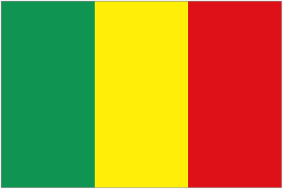  Flag of Mali | 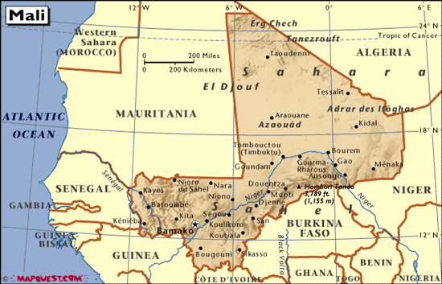  Map of Mali
- Major Parties Involved
- National Movement for the Liberation of Azawad
- 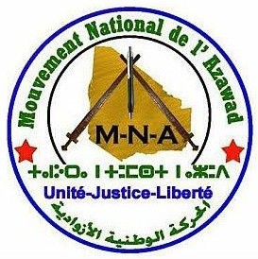
The Tuareg Rebellion of 2012 was led by the MNLA against the Malian government to gain autonomy of the Azawad region.

- Islamist group Ansar Dine
- 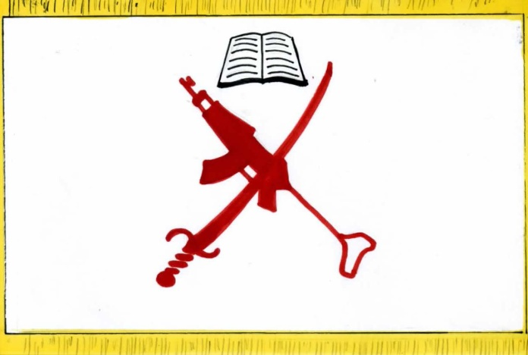
- Ansar Dine got involved in the late stages of the war when they claimed the same territory the MNLA was fighting for which caused escalated tension between the two fronts.

- Malian Government and Army
- 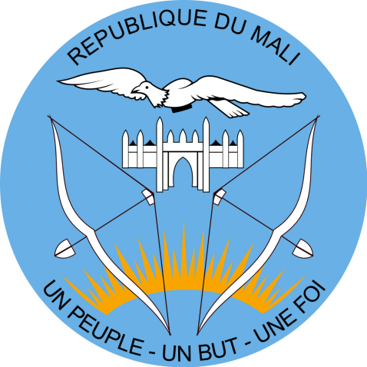
The Malian Government could not protect itself from the insurgents as they were militarily not well equipped for war. For Mali to regain its sovereignty as a nation-state, it needed international military intervention.

- MINUSMA
- 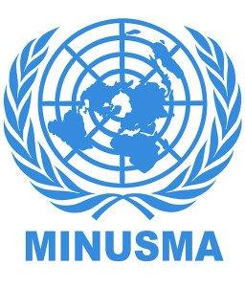
This is the UN led peacekeeping mission in Mali. The UN intervened in Mali on the first of July 2013 where it deployed its troops to regain the Azawad region and stabilize the situation in Mali.

Timeline of Events
Date | Event
1962–1964 | Tuareg Rebellion
1990–1995 | Tuareg Rebellion
2007-2009 | Tuareg Rebellion
16 January 2012 | Start of the Tuareg Rebellion in the northern region of Mali
March 2012 | The Islamist group Ansar Dine fight the government claiming control of vast territory
21 March 2012 | President Amadou Toumani Touré was overthrown in a coup d'état
22 March 2012 | Rebels capture the three biggest cities in the north: Gao, Timbuktu and Kidal
6 April 2012 | proclaimed Azawad's independence from Mali
17 July 2012 | Ansar Dine had pushed the MNLA out of all the major cities
14 February 2013 | the MNLA renounced their claim of independence for Azawad and asked the Malian government to start negotiations on its future status
25 April 2013 | MINUSMA, the UN peacekeeping mission in Mali is established
1 July 2013 | MINUSMA deploys troops

Previous Attempts to Solve the Issue
Resolution 2100 of 25 April 2013
When MINUSMA was established by the Security Council Resolution 2100 of 25 April 2013, it was to support political processes in Mali and carry out a number of security-related tasks. The aim of the Mission is to support the transitional authorities of Mali in the stabilization of the country and implementation of the transitional roadmap.
Resolution 2164 of 25 June 2014
When Resolution 2164 of 25 June 2014 was adopted unanimously, the Security Council decided that the Mission should focus on duties, such as: ensuring security, stabilization and protection of civilians; supporting national political dialogue and reconciliation; and assisting the reestablishment of State authority, the rebuilding of the security sector, and the promotion and protection of human rights in Mali.

Possible Solutions & Approaches
- When Evaluating the progress of the MINUSMA mission in Mali, the delegate must take into account the UN resolutions and reports to evaluate whether Mali’s situation has been declining or improving. The delegate should analyze and find trends in the data provided by the UN to see whether there has been progress in the UN’s peacekeeping mission in Mali.

- Delegates should not treat this conflict as a two-sided conflict as there are more than just two fronts. In Mali, ISIL is posing a threat to its sovereignty, the Tuareg rebels may rise again to regain Azawad as it is a repeating pattern in history. Mali’s Army is in dire need of the UN for protection and development.

- Delegates should understand that the territorial disputes within Mali are due to ethnic affiliations as only 10% of the population is Toureg and view Azawad as their ancestral home. The majority of the population is of the Mande ethnic group, exceeding 50% of Mali’s population.

- Delegates should also investigate what the UN peace keeping troops are doing in Mali.

Useful documents and sources
Background information on the MINUSMA mission in Mali:
http://www.un.org/en/peacekeeping/missions/minusma/background.shtml

Facts & Figures of the MINUSMA mission:
http://www.un.org/en/peacekeeping/missions/minusma/facts.shtml

UN Statistics on MINUSMA mission:
http://www.un.org/en/peacekeeping/resources/statistics/contributors.shtml

UN Peacekeeping mission in Mali:
http://www.un.org/en/peacekeeping/missions/minusma/

News on MINUSMA mission:
http://minusma.unmissions.org/en

Report of the Secretary-General on the situation in Mali, 31 May 2016:
http://minusma.unmissions.org/sites/default/files/n1614458-en.pdf

Resolution 2100 of 25 April 2013: MINUSMA established by Security Council to support political processes in Mali and carry out a number of security-related tasks:
http://www.un.org/en/peacekeeping/missions/minusma/documents/mali%20_2100_E_.pdf

Resolution 2164 of 25 June 2014: the Council further decided that the Mission should focus on specific duties:
http://www.un.org/en/ga/search/view_doc.asp?symbol=S/RES/2164(2014)

Security Council Resolution 2295 of 29 June 2016:
http://www.un.org/en/ga/search/view_doc.asp?symbol=S/RES/2295(2016)

