Forum: African Union
Issue: Promoting sexual education for sexual minorities
Student Officer: Adam Solčanský
Position: Chair

Introduction
Sexual education is a basic part of all education programmes worldwide and necessary for the prevention of diseases, transmitted by sexual contact, and for women’s right. In African countries with lower levels of education, many people perform local sexual “traditions”. FGM and HIV transmission are two main problems in Africa needed to be solved in the near future. According to WHO, 1.1 million people died of HIV-related illnesses worldwide in 2005, most of which occurred in Africa: 800 000.
In many African countries, women don´t have a stable position in society. This sometimes leads to sexual violence on young women, FGM and growing AIDS epidemics. Furthermore, sexual violence as a silent act of war touches all women, even those younger than 15 years.

Definition of Key Terms
AIDS
AIDS is a disease caused by the virus HIV, mainly transmitted by sexual contact.

HIV
This virus causes HIV infection and it causes AIDS over time. Without treatment, average survival time after infection is estimated to be 9 to 11 years. The virus can be transmitted via blood, semen, vaginal fluid, pre-ejaculate or breast milk.

FGM
Female genital mutilation is a ritual removal of some or all external parts of female genitalia.
Other terms in common use are: FGC (female genital cutting) and FGM/C (female genital mutilation/cutting).

Sexual violence
A sexual act committed against someone without that person’s freely given consent.

General Overview
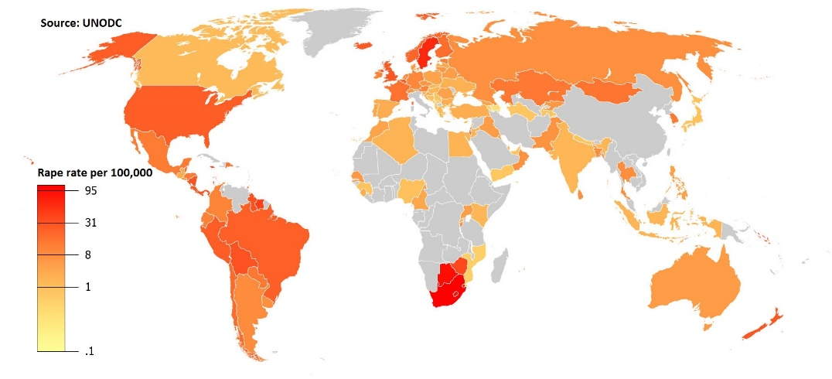
Diseases are quite often spread by non-educated people as a consequence of their low level of knowledge, including prevention and risks of the diseases.
It seems like many people in Africa don´t care about spreading AIDS among the population, but it might be the case that they are simply not aware of the consequences of the disease, due to a lack of education, even after all information that has been spread around the world.
An additional problem is that condoms are often inaccessible for African people, which means that the disease spreads faster among people.
In general, the level of sexual education in African countries is either very low or there is none at all, which causes an insufficient knowledge of the risks the people are being or will be exposed to.
In many cases, AIDS is spread due to sexual violence during wars. The victims are normally not immediately aware of the infection, but it kills them years later. Sexual violence as a silent act of war concerns all women living in areas suffering from armed conflict.
Moreover, the social level of women in many African countries often deteriorates the situation, where men are seen as more important than women. After having become victims of sexual violence, the women are often not properly helped due to their social position and in many cases, the problems regarding sexual violence are not discussed in public because of shame or blame. Only the fatal cases are reported to the police, which is about half of all cases reported to the police.
There is also a huge number of domestic sexual violence, even of women younger than 15 years.
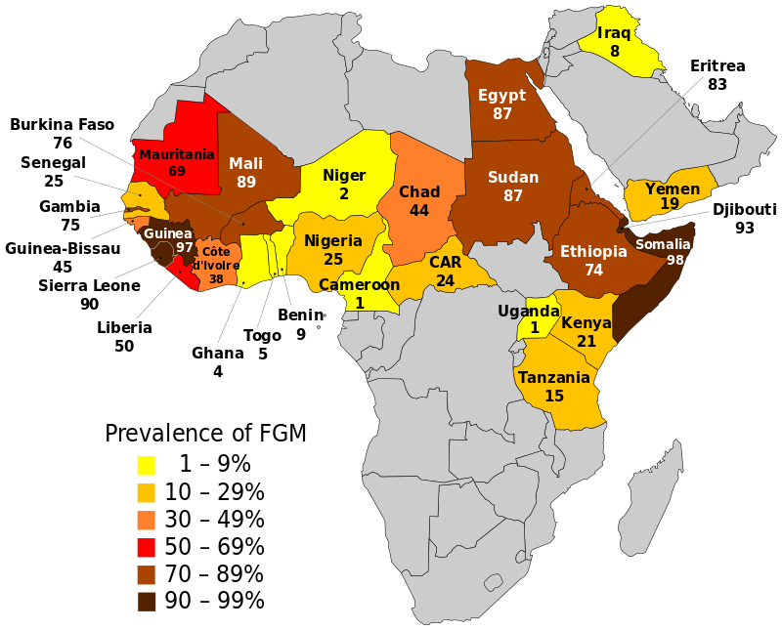
FGM or female genital mutilation is a well-known ritual executed in 27 countries in Africa, mainly in Djibouti, Egypt, Eritrea, Guinea, Mali, Sierra Leone, Somalia and Sudan. About 80 to 98% of all women with ages ranging from 15 to 49 years are suffering from this ritual. UNICEF estimated that in 2016 at least 200 million girls and women in 30 countries across three continents have undergone this ritual.
The main goal of this report is to point at the gender inequality, which is also shown in sexual violence. Since 2007, FGM is recognized as a human right violation. In 2015, 23 out of 27 African countries made laws to restrict FGM.

Major Parties Involved
UNICEF
UNICEF is a UN-body that started to promote an evidence-based social norms approach to FGM in 2003 and in 2005, UNICEF published its first report on this subject. In 2008, UNICEF combined forces with UNFPA (a UN-agency of which the goal is to help girls and women lead a healthy and productive life) and they established a joint programme that should reduce FGM by 40% among girls younger than 15 years.

African Union
The African Union ratified a Maputo protocol on the rights of women in 2003. This protocol includes a clause stating that States Parties have to protect all women from all forms of violence, particularly sexual and verbal violence. Another clause states that all States Parties a change of the social and cultural patterns of conduct of women and men should be achieved through, among other things, public education.

UNESCO
In 2009, UNESCO published the first global guidance on sexuality education, in collaboration with UNAIDS, UNFPA, UNICEF and WHO. This guidance seeks to assist education, health and other relevant authorities to develop and implement school-based sexuality education materials and programmes.

Possible Solutions
A possible solution to this problem concerning sexual education consists of establishing or developing an existing education programme which can solve all issues among non-educated people.
It has been observed that the problems regarding sexual violence, FGM or the spread of AIDS are mostly common in war zones, among people from poor families and areas with no proper access to information.
Therefore, a programme to solve this issue should include a way to develop the level of education in the entire continent of Africa, a mediation of information, emphasis on women’s rights, etc. It´s a long time process in the most unstable part of the world.

Appendix/Appendices and useful documents
Wikipedia articles:
https://en.wikipedia.org/wiki/Sexual_violence_in_South_Africa#Violence_against_women
https://en.wikipedia.org/wiki/Sex_education#Africa
https://en.wikipedia.org/wiki/Female_genital_mutilation

The world report about sexual violence:
http://www.who.int/violence_injury_prevention/violence/global_campaign/en/chap6.pdf

UNESCO sexual education programme:
http://www.unesco.org/new/en/hiv-and-aids/our-priorities-in-hiv/sexuality-education/

The Maputo protocol of the African Union:
http://www.achpr.org/files/instruments/women-protocol/achpr_instr_proto_women_eng.pdf

