Forum: Special Conference onWorld Food Security
Issue: Food loss and food waste in MEDCs
Student Officer: Alla Malashevskaya
Position: Deputy Chair
Disclaimer: this research report has not been checked by the LEMUN staff

Introduction
Up to one third of all food is spoiled or squandered before it is consumed by people. It is an excess in an age where almost a billion people go hungry, and represents a waste of the labour, water, energy, land and other inputs that went into producing that food. The causes on food waste in medium and high-income countries relate mainly to consumer behavior and the policies and regulations put in place to adress other sectorial priorities. For example, agricultural subsides may contribute to the production of surplus quantities of farm crops of which at least a proportion is lost or wasted. Food safety and quality standards can be applied in ways that remove food that is still safe for human consumption from the food supply chain. At the consumer level inadequate planning of purchases and failure to use food before its expiry date also lead to avoidable food waste.
One-third of food produced for human consumption is lost or wasted globally, which amounts to about 1.3 billion tons per year
Food is lost or wasted throughout the supply chain, from initial agricultural production down to final household consumption
Food losses represent a waste of resources used in production such as land, water, energy and inputs, increasing the green gas emissions in vain.
Definition of Key Terms
- Food loss is the decrease in quantity or quality of food. Food loss in the production and distribution segments of the food supply chain is mainly a function of the food production and supply system or its institutional and legal framework.
- Food waste (which is a component of food loss) is any removal of food from the food supply chain which is or was at some point fit for human consumption, or which has spoiled or expired, mainly caused by economic behaviour, poor stock management or neglect.
- The Food and Agriculture Organization of the United Nations (FAO) leads international efforts to defeat hunger.

General Overview
Food loss and waste have negative environmental impacts because of the water, land, energy and other natural resources used to produce food that no one consumes. The size of the impact in- creases with the level of processing and refining of the food products, and the stage(upstream or downstream) in the food supply chain at which the food is lost or wasted. Generally, lower losses are associated with higher efficiency in the food supply, and eventually with more effective recycling of resources, lower storage needs, shorter transport distances, and less energy use. However, solutions for reducing losses often lead to increased use of energy, especially for the preservation of food products. Obviously, from the environmental point of view, the negative impacts of measures to reduce food loss and waste should be lower than the benefits. The non-productive use of natural resources such as land and water that results from food loss and waste has repercussions on hunger and poverty alleviation, nutrition, income generation and economic growth.
Women farmers and young children in many developing countries are particularly likely to suffer this impact, as they often have less access than other groups to appropriate technologies, infrastructure, storage facilities and markets. Qualitative food loss may cause reduced nutritional status, while low-quality products may also be unsafe because of their adverse effects on the health, well-being and productivity of consumers Food loss represents a loss of economic value economic value for actors in the food production and supply chains. The value of food lost or wast ed annually at the global level is estimated at US$ 1 trillion. Today's food supply chains are in creasingly globalized, with certain food items being produced, processed and consumed in very different parts of the world. Food commodities traded on markets and wasted in one part of the world could affect food availability and prices in other parts.

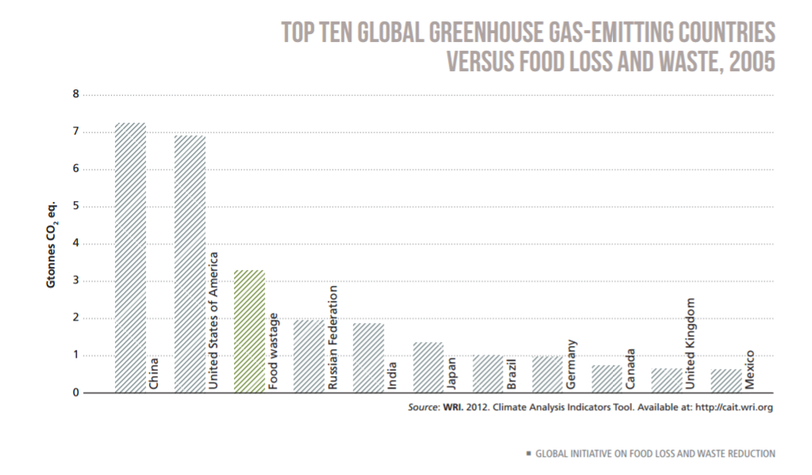
Major Parties Involved

European Union
Concurrently, all Member States of the European Union shall establish frameworks to collect and report levels of food waste across all sectors in a comparable way. The latest data are requested to develop national food waste prevention plans, aimed to reach the objective to reduce food waste by at least 30% between 1 January 2017 and 31 December 2025. To enable the process, the Commission shall adopt implementing acts by 31 December 2017 in order to establish uniform conditions for monitoring the implementation of food waste prevention measures taken by Member States of the EU.

United Nations
Under the UN's Save Food initiative, the FAO, UNEP and stakeholders there has been taken all the directives and programms for the future development.

Timeline of Events
16 October to 1 November 1945. | The First Session of the FAO Conference
1996 | World Food Summit
2002 | The Alliance Against Hunger and Malnutrition (AAHM)
2015 | Resolution on food waste

Previous Attemps to solve the issue
Directive 2008/98/EC sets the basic concepts and definitions related to waste managament, such as definitions of waste, recycling, recovery. It explains when waste ceases to be waste and becomes a secondary raw material (so called end-of-waste criteria), and how to distinguish between waste and by-products. The Directive lays down some basic waste management principles: it requires that waste be managed without endangering human health and harming the environment, and in particular without risk to water, air, soil, plants or animals, without causing a nuisance through noise or odours, and without adversely affecting the countryside or places of special interest.

In June 2015, our Board of Directors agreed a resolution on food waste, with the aim of halving the amount of food wasted within the operations of our retailer and manufacturer members by 2025. The Resolution is of voluntary character, but authoritative (non-binding in a legal sense). It was voted upon by the Board on behalf of our members.

This resolution focuses on two key areas: preventing food waste, then maximizing its recovery towards the goal of halving food waste within the retail and manufacturing operations of CGF’s 400 members by 2025 versus a 2016 baseline, and contributing to the United Nations goals by 2030 to halve per capita global food waste at the consumer level; and reduce food losses along production and supply chains, including post-harvest losses, and maximize the value of the remaining waste.

Possible Solutions

Because of the magnitude and complexity of the food loss and waste problem, the UN recognizes the need to undertake action in partnership with other regional and international organizations, and with food chain actors ranging from herders, farmers and fishers to global companies. Partnerships are equally important in mobilizing the resources required for action.
The approach to reducing food loss and waste is embedded in the broader concept of promoting sustainable food systems, which encompasses sustainable food production on the one hand, and sustainable diets and consumption(such as through the reduction of food waste) on the other. Measures for re ducing food loss and waste have to be environmentally sustainable and should foster food and nutrition security.
The integrated food supply chain approach takes into account the possibility that food loss and waste in one part of the chain are caused in another part. Solutions and strategies focus on systemic improvements of the efficiency and sustainability of food supply chains. From an economic point of view, supply chain actors will adopt food loss and waste reduction measures only if they are profitable or at least cost-effective. Differences in the productive and social roles of men and women actors in supply chains must also be ac knowledged and addressed.
Addressing food waste: the issue of food waste is high on the political agenda in industrialized countries. Food waste is expected to constitute a growing problem in developing countries given the changes that food systems in these countries are undergoing because of such factors as rapid urbanization, expansion of supermarket chains, and changes in diets and lifestyles. The strategy therefore addresses food waste reduction taking into consideration the need for unique approaches and interventions that differ from those for tackling losses. The Save Food Initiative gives priority to interventions that prevent food loss and waste from occurring in the first place, followed by interventions that can lead to reduced loss and waste. The initiative also supports cost-effective and environmentally friendly reuse(such as for animal feed) and recycling(as compost) of lost and wasted food.

Useful documents

http://www.fao.org/save-food/news-and-multimedia/news/news-details/en/c/414156/
http://www.fao.org/documents/card/en/c/91fa7138-d4c5-438e-9398-7d8070728d97/
http://www.fao.org/save-food/resources/casestudies/en/
http://www.fao.org/documents/card/en/c/bc8d9945-d7d3-4f7e-926f-744acc7dab9e/
http://www.fao.org/documents/card/en/c/27cf409c-6235-4c2d-8c5a-5461bc92a733/

Appendix/Appendices

http://www.fao.org/save-food/en/

http://www.fao.org/countryprofiles/en/

http://www.save-food.org/cipp/md_ip/custom/pub/content,oid,47046/lang,2/ticket,g_u_e_s_t/~/About.html
http://www.un.org/waterforlifedecade/food_security.shtml

