Forum: General Assembly Fourth Committee
Issue: Combating nationalism and religious extremists in the Balkans
Student Officer: Sangho Yoon
Position: Deputy Chair
Disclaimer: this research report has not been checked by the LEMUN staff

Introduction
The Charters of the United Nation established the general assembly of the United Nation in 1945. The assembly’s purpose is to provide a place and a forum for the leaders of all the nations of the world to discuss about international issues. The 192 nations of the General Assembly discuss and debate to produce a resolution that will make recommendations to the States. General Assembly’s decision can’t overpower the natural sovereignty of the states.

The conflict in the Balkan Peninsula is problem of the world that the General Assembly can’t ignore. The people of Balkan Peninsula has suffered through war and conflicts through out the twentieth century. The major wars were the First and Second Balkan Wars and Yugoslav wars. These wars and conflicts are the result of the diverse ethnicities and political upheavals. The additional financial problems that have been arising are causing the lives of the citizens of Balkan more unbearable.

These conflicts are driven from the years of hatred and differences. The Balkan Peninsula is unique for its diverse ethnicity. There are also three major religions involved in the Balkan Peninsula: Islam, Roman Catholic, and Eastern Orthodox. Without the context of the region resolving the issues maybe impractical and even impossible.

Definition of Key Terms
Balkan Peninsula:
The Balkan Peninsula is located in the south east of the Europe Continent. The region compromises of Albania, Bosnia and Herzegovina, Bulgaria, Croatia, Kosovo, Macedonia, Montenegro, Romania, Serbia, and Slovenia. Geographically, parts of Greece and Turkey are defined to be in parts of the Balkan Peninsula.
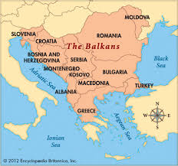

Annexation:
Defined by the Encyclopedia Britanica, Annexation means, “a formal act whereby a state proclaims its sovereignty over territory hitherto outside its domain. Unlike cession, whereby territory is given or sold through treaty, annexation is a unilateral act made effective by actual possession and legitimized by general recognition.”

Yugoslavia:
Yugoslavia was a formal state in the Balkan Peninsula. Yugoslavia means “lands of south Slavs”. Yugoslavia became an independent nation in 1918 after the World War I. The nation of Yugoslavia was founded on the land of Kingdom or Serbia, Montenegro, and Austria – Hungary. After the fall of Soviet Russia and the economy downturn, the Kingdom of Yugoslavia started to breakdown into different nations according to the League of Communist. It broke down into Bosinia and Herzegovina, Serbia, Macedonia, Croatia, Serbia, and Slovenia due to the war of Yugoslavia and many years of tensions.

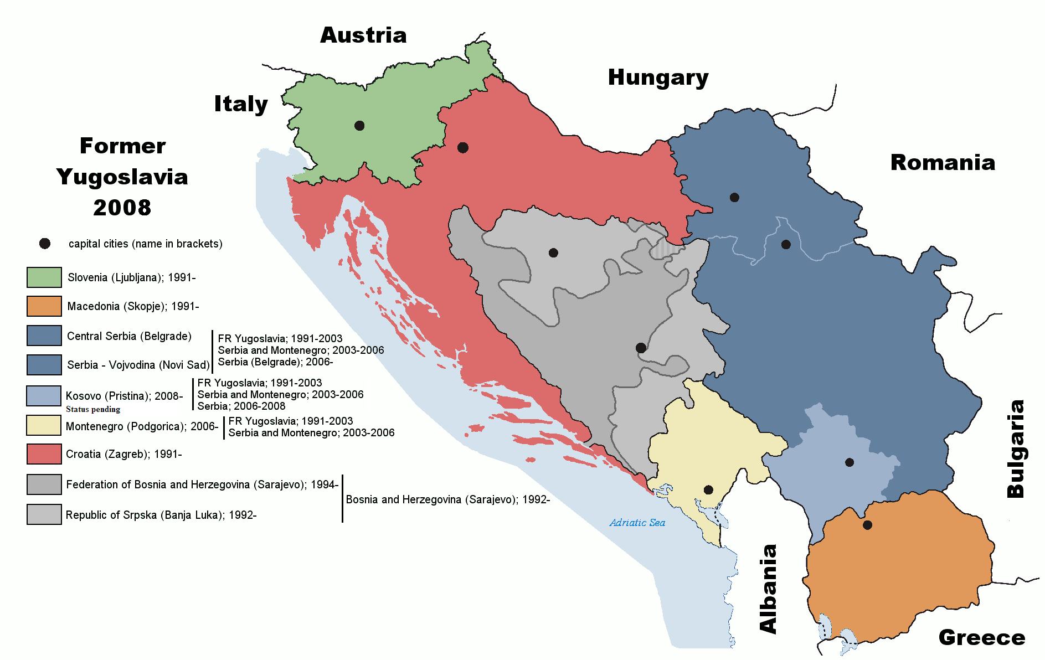

Citizen:
The Random House Dictionary of the English Language defines it as "1. A native or
naturalized member of a state or nation who owes allegiance to its government and is
entitled to its protection. 2. An inhabitant of a city or town, esp. one entitled to its
privileges or franchises."

General Overview
The region of Balkan Peninsula has been the arsenal of the Europe continent. It is infamous for its long and unending conflicts that have been embodied with in the citizens’ mind. The most important conflict that affected the world originated from the Balkan Peninsula. The assassination of Austro-Hungarian prince, Franz Ferdinand, by the Serbian nationalist started the World War I.

After the end of World War I, the Kingdom of Yugoslavia was established in the land of Kingdom or Serbia, Montenegro, and Austria – Hungary. The diverse ethnicity of the region would have meant that there would be conflicts within. The first president of the Yugoslavia, Josip Broz Tito controlled the issue well by suppressing nationalism, but after the death of Tito everything went to misery.

The following of 1980s recession of the economy of Yugoslavia, nationalism, and fall of the Soviet Union made the Kingdom of Yugoslavia a time bomb waiting to explode. In 1889 the leader of Serbia, Sloboan Milosevic, took control over the Vojvodina and Kosovo. The leader of Slovenia criticized Serbia for its action, but the autonomy of Kosovo has been taken away.

Majority of the Kosovo’s citizens are the part of Albanian ethnicity making the Serbian the minority. This fact brought upon active measures by the Albanian government. While the tension grew, Serbia and Slovenia disagreed on the future of the Yugoslavia. Serbia wanted a unified government, and, in the other hand, Slovenia wanted more individual governance. This dispute of idea led into the upcoming separation of League of Communist of Yugoslavia.

Croatia declared to be an independent nation (1991), but the large percentage of Croatian citizens was Serbian ethnicity. This brought worries to the Serbian people. The last time Croatia declared an independent state (Independent State of Croatia 1941-1945) resulted in a nationalistic government, which took part in the Holocaust during the World War II. The worried citizens started a revolution, which was supported with military weapons by Serbia. Slovenia also declared independence around this time. As a response, Yugoslavia used military force to ask the two nations to reconsider their independence, and this conflict led into the Yugoslav War.

Large percentage of Croatia was Serbian people. Serbia wanted to protect their citizens who were living in Croatia. The army of Yugoslavia (Serbia) joined forces with the rebels and took over the cities of Croatia, declaring that it is for the protection of its citizens. The problem intensified by the army taking control over the cities, which had a majority of Croatian ethnicity. This meant that Serbia wanted more than just the protection of its citizen.

The Arbitration Commission of the Peace Conference set up by the European Economic Community on Yugoslavia tried to resolve the conflict and war between Croatia and Serbia. The vote was done to the favour of Croatia, but it was later on rejected as there were outside influence on Montenegro. In the end, the conflict between Croatia and Serbia ended with the Sarajevo Agreement.

The biggest conflict on the Balkan Peninsula was in the Bosnia and Herzegovina. Bosnian citizens were comprised of three major ethnicities: Bosnian (Muslim), Serbian, and Croatian. The rebel of Bosnian Serbians and Bosnian Croatians demanded to be an independent state or to be part of Serbia or Croatia. The war between three forces led into civilian casualties. The Muslim Bosnian citizens were being massacred. UN and NATO forces demanded Serbia to stop assaulting civilians but the offers were rejected. In the end, NATO sent air strikes on the Bosnian Serbian army camps.

In 1995, Croatian declared war against the Bosnian Serbian rebels with stronger military force than before. The conflict in Bosnia ended with the intervention of US. US suggested dividing Bosnia as two legal entities (Dayton Agreement), and all members agreed and sign the peace treaty.

In the late 1990s, the Albanian majority in Kosovo sought for independence from Serbia. The war ended in 1999 and Kosovo declared independence in 2008 but is still not considered as a nation by the majority of the world.

The migrants from North Africa and Syria passing through the illegal pathway of Turkey into the Balkan Peninsula are a serious issue. With the issues that Balkan Peninsula has faced previously, the issue of migrants can be a start to another conflict in the Balkan region. It can make the region’s ethnicity more diverse or give power to the Muslim population of Bosnia.

Major Parties Involved
[Serbia]
The Kingdom of Serbia has been the major party of the conflict in Balkan. The Kingdom of Serbia fimly believes that the Serbian people outside the nation should be protected by Serbia. Also, the nation has claimed that it was the rights and choice of the citizens to be part of Serbia for their safety and prosperity. The Serbian government suggests that the Serbian citizens were threatened by the independence of the nations. The claims of Serbia is due to the fact that majority of Croatian and Bosnian citizens are Serbian ethinicity.

[Bosnia and Herzgovina]
Bosnia and Herzgovina was affected by the wars the most. Bosnia and Herzgovina consists of the three ethnicities: Bosnian, Croatian, and Serbian. Bosnia has gone through the most devastating war in the Balkan. Its citizens suffered through many massacres done by the Bosnian Serbian rebels and Serbian military forces. The issue is intensified, as it was the Muslim population who were the target of the rebels throughout the war.

[Croatia]
Croatia was also heavily affected by the war in Balkan. Croatia is not fond of the actions done by the government of Serbia. The government of Serbia demanded a part of Croatia be annexed into Serbia due to the ethnicity and the demand of the citizens. Croatia believes that the actions of Serbia were disrespectful of the sovereignty of Croatia.

[NATO]
The NATO involved in the conflict of Bosnian and Herzegovina to protect the citizens. NATO allowed the deployment of the UN peacekeeping forces. The purpose of the NATO was to protect and to promote peace, but the campaign ended with the deployment of soldiers and air raids on the army basecamps of Serbia. The international forces don’t want to intensify or take part in any of the sides of the conflict. Their soul purpose is to protect the citizens.

Timeline of Events
Dates | Events
1912-13 | Two Balkan Wars are fought.
1914 | Serbia occupies Kosovo and Macedonia.  Archduke Franz Ferdinand is assassinated.  World War I begins.
1919 | The Treaty of Versailles forms Kingdom of Yugoslavia.
1941 | Adolf Hitler attacks Yugoslavia and creates a Croatian Republic.  Serbs are sent to death camps.
1945 | World War II ends
1946 | Tito and Communists take over Yugoslavia.
Early 1980s | Economic Crisis
1980 | Josip Broz Tito dies.
1991 | Outbreak of Yugoslav War.
1994 | NATO enters conflict. (air strikes)
1995 | Dayton Agreement: Ends Yugoslav War, divides Bosnia into two legal entities.
1996 | International Criminal Tribunal relating on Balkan Wars begins.  Kosovo Liberation Army starts fighting for its freedom.
1999 | NATO intervenes with air strike.
2008 | Kosovo declares independence.

Previous Attempts to solve the issue
- Security Council Resolution 820
- Security Council Resolution 836 (1993)
- Security Council Resolution 844
- Security Council Resolution 859
- Security Council Resolution 871
- United Nations Security Council Resolution 908
- United Nations Security Council Resolution 913
- Kumanovo Agreement (1999)
- Dayton Agreement
- NATO air strikes (Operation Deliberate Force)

Possible Solutions
The conflicts in the Balkan Peninsula have been present for a century. There hasn’t been a cease in the conflict ever since. The only time it was peaceful was under the reign of Tito of Yugoslavia. Tito was successful, because Tito supressed nationalism and promoted brotherhood among the nations. To find the solution to the problem, one must look into its complicated past and understand the stances of every nation.

First of all the root of the problems of Balkan comes from the diverse ethnicity and deep historical hatred between the nations. The nations of the Balkan can deal with the situation by possibly getting closer relationship with each other. This mutual relationship can be formed by a conference specifically for the Balkan region. There is no opportunity for the nations of Balkan to meet and discuss about their future. There can be a conference opened annually for the leaders of the Balkan nations to join and discuss about the future and forming new alliances.

The states of the Balkans can form better relationship with each other with a proper apology from the state of Serbia or Croatia for the past crimes of massacring innocent citizens. Even in the cold state of diplomacy sometimes a warm apology is all that is needed. This need for apology can be a great solution looking at the example of Germany. Germany has spent many efforts of showing their apologetic stances with the victims of the holocaust. The history can never be erased, but the attitude that the Germany brings prevented any serious hostility to rise against them.

Finally, the Balkan Peninsula can be united and have more affection to each other by recognizing Kosovo as an independent nation. Recognizing independent nations were the start of the conflicts in the Balkan region. By recognizing Kosovo as free and independent state, the nations of Balkan can have a fresh new start for the region. It is putting aside the claims of ethnicity and protections of citizens. This act would mean that the nations of Balkan would respect the sovereignty of the other nations in the future.

Useful documents
http://www.ejil.org/pdfs/14/5/455.pdf

The Role of the United Nations in the Balkans by Yasushi Akashi
https://www.dur.ac.uk/ibru/publications/download/?id=70

https://www.youtube.com/watch?v=oiSgAiM0d8A

Appendix/Appendices
https://www.britannica.com/place/Balkans

https://en.wikipedia.org/wiki/Balkan_Wars

https://www.britannica.com/place/Yugoslavia-former-federated-nation-1929-2003

https://en.wikipedia.org/wiki/Yugoslavia

http://www.nytimes.com/2016/03/10/world/europe/europe-refugee-crisis.html?_r=0

http://www.ifimes.org/en/8126-balkan-conflict-and-its-solutions-creating-conditions-for-peace-stability-and-development

